

**Supporting Information for**

The fate of the endemic South American mammal fauna in response to the most dramatic Cenozoic climate event

Lucas Buffan1,*, Fabien L. Condamine1, Narla S. Stutz1, François Pujos2, Pierre-Olivier Antoine1, Laurent Marivaux1

1 Institut des Sciences de l’Evolution, Université de Montpellier, CNRS, IRD, Place Eugène Bataillon, 34095 Montpellier cedex 5, France  
2 IANIGLA, CCT–CONICET–Mendoza, Avenida Ruiz Leal s/n, Parque General San Martín, 5500 Mendoza, Argentina

* Lucas Buffan

**Email:** Lucas.Buffan@umontpellier.fr

**This PDF file includes:**

Figures S1 to S37

Tables S1 to S8

SI References

**Other supporting materials for this manuscript include the following:**

Dataset S1

Manual cleaning details.

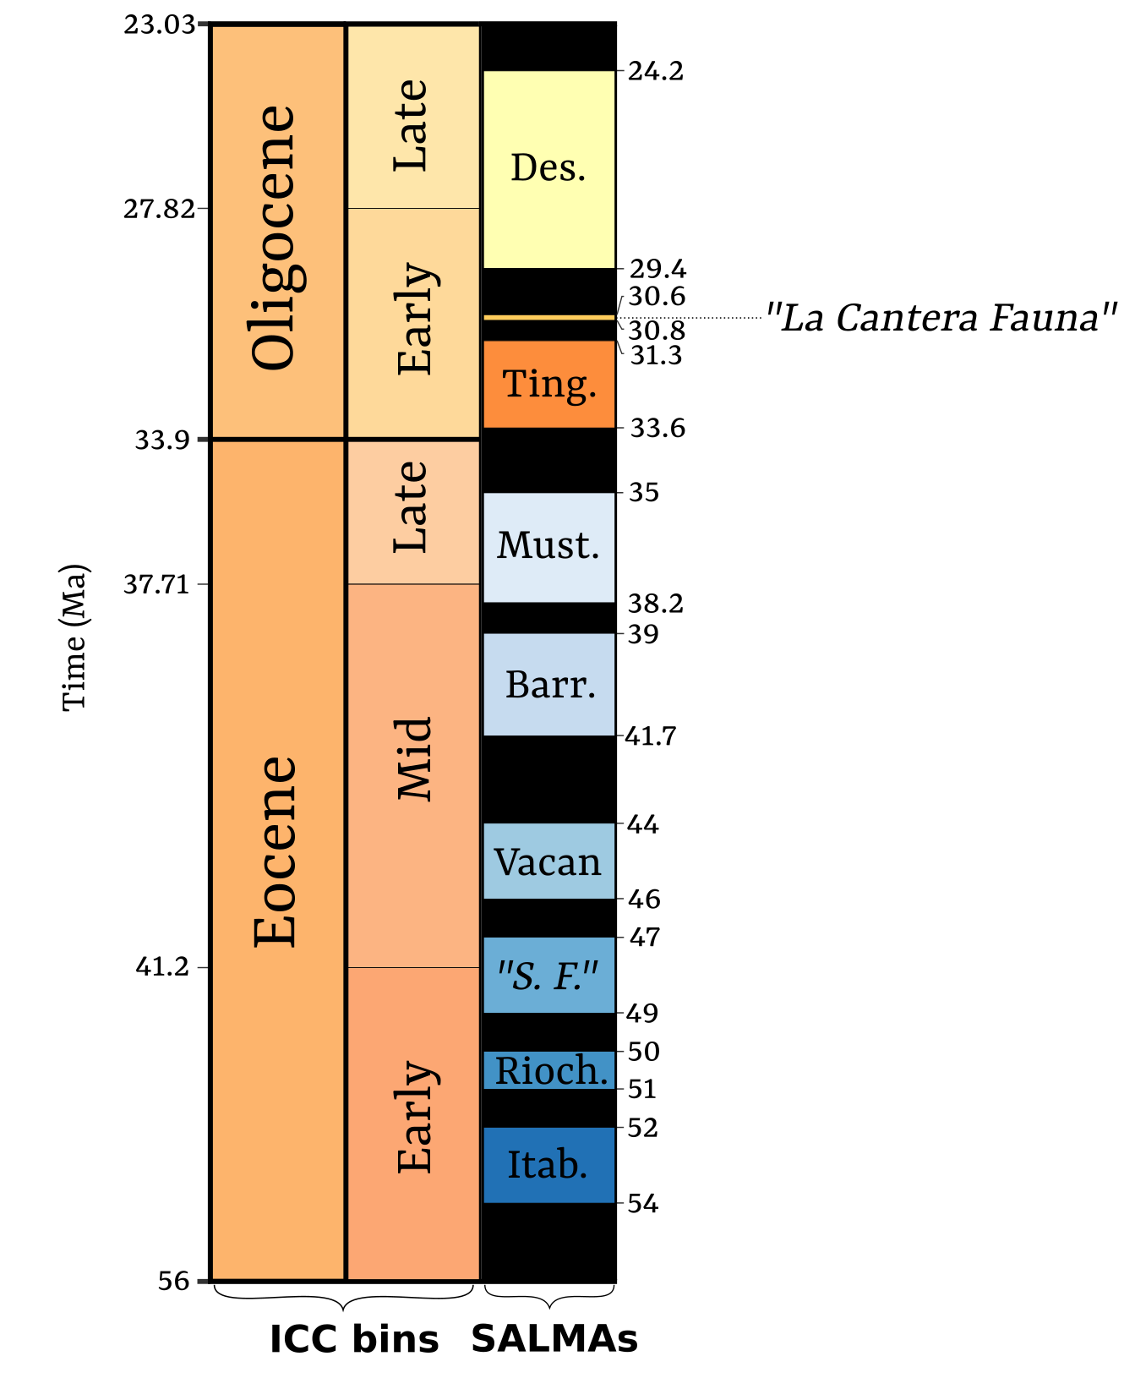

**Figure S1.** Time bins used in this study.Bins representing International Chronostratigraphic Chart 2022 (ICC bins) geological epochs (leftmost vertical band) and sub-epochs (middle vertical band), and representing South American Mammal Ages (SALMAs, rightmost vertical band) are depicted. SALMA boundaries were determined from [Dunn et al. (2013), Woodburne et al. (2014) and Kouvari (2023)](https://www.zotero.org/google-docs/?vDT9pq). Note that an absolute estimate does not exist for the majority of them. Black rectangles stand for gaps in the South American mammalian fossil record.  
*Abbreviations for SALMAs. Des: Deseadan, Ting: Tinguirirican, Must: Mustersan, Barr: Barrancan, “S. F.” : “Sapoan Fauna”, Rioch: Riochian, Itab: Itaboraian.*

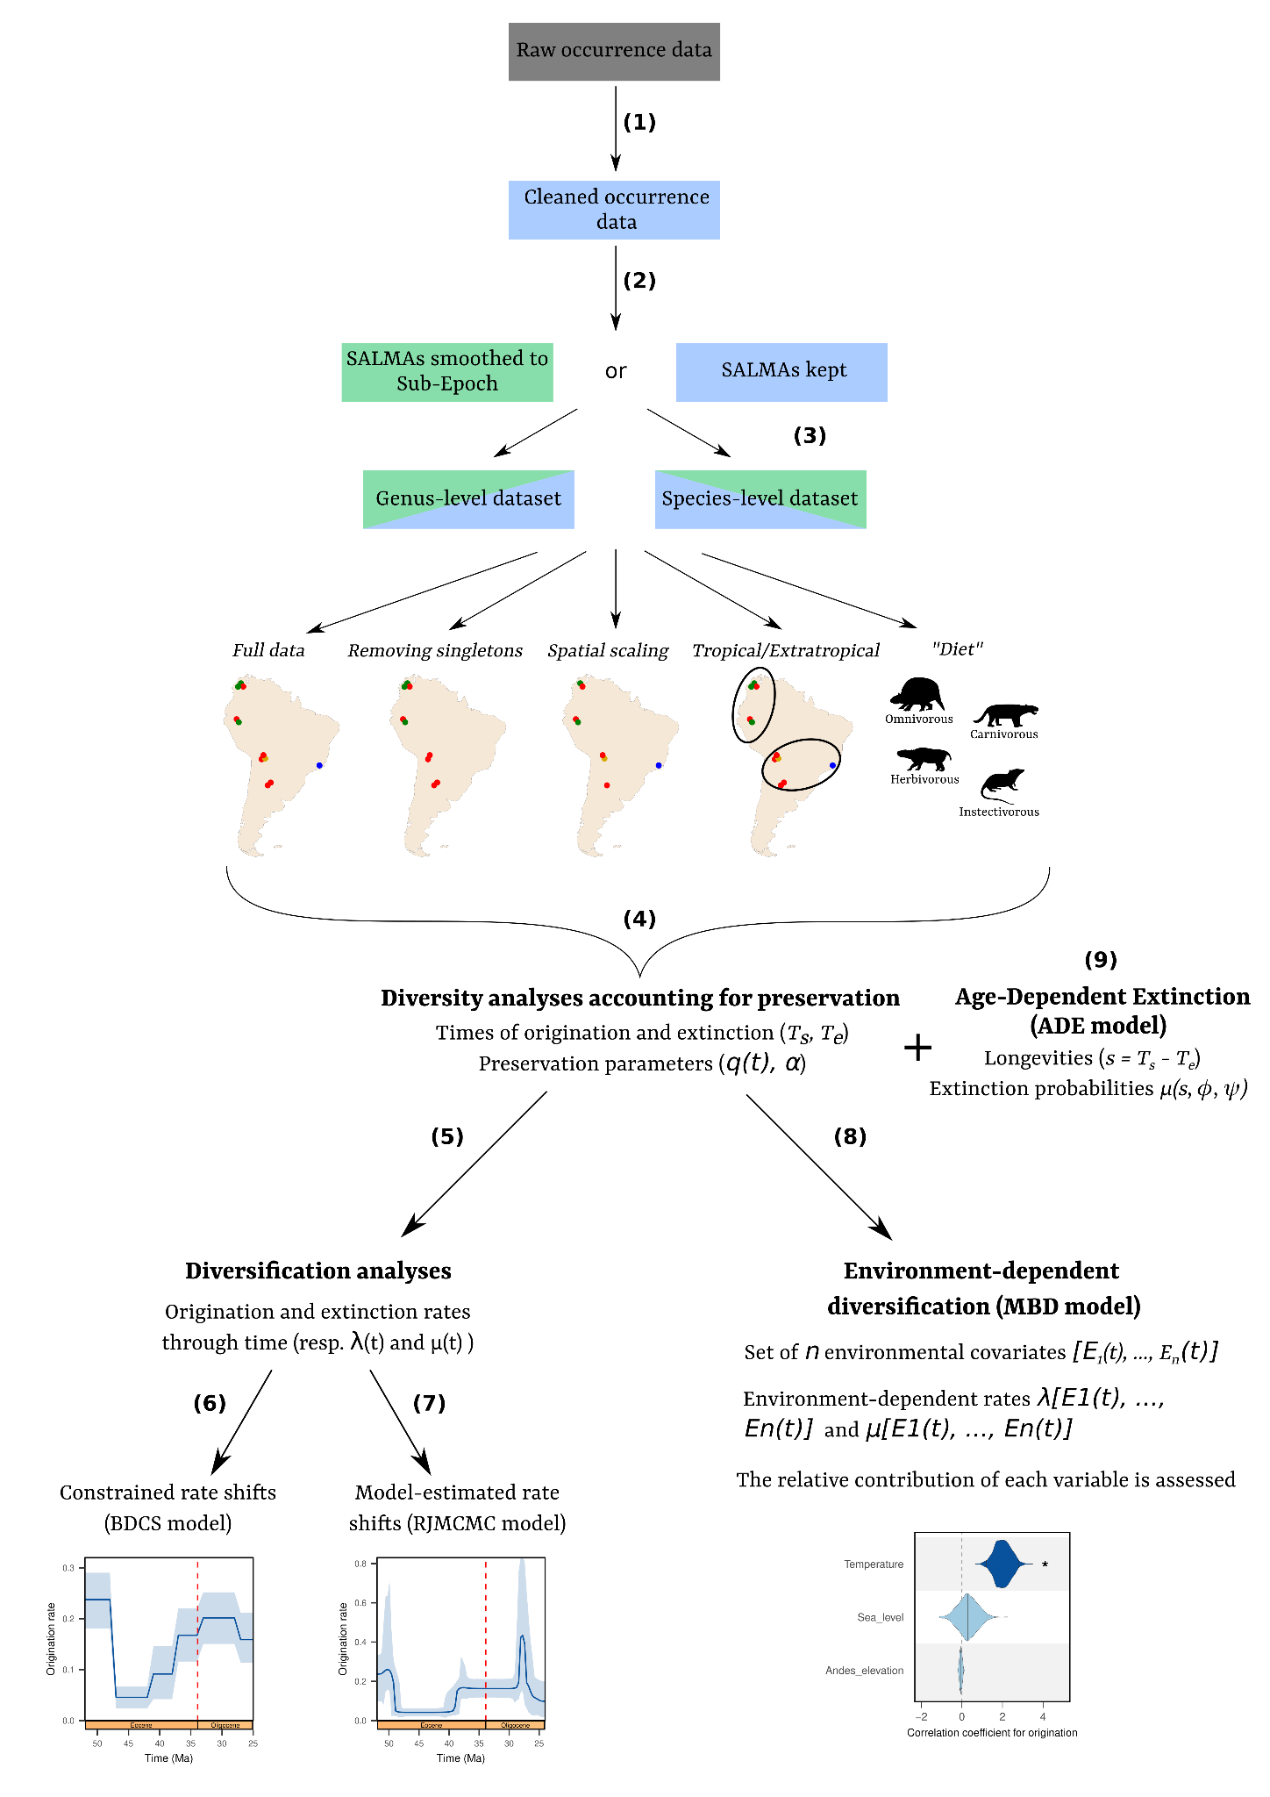

**Figure S2.** Schematic view of our data methodological pipeline. We downloaded our data on The Paleobiology Database (<https://paleobiodb.org/>). We made sure to match each occurrences’ time range with the boundaries of its corresponding interval, either being a geological stage/epoch (55% of our occurrences) or a South American Land Mammal Age (SALMA) (45% of our occurrences). Then, we cleaned the data, verifying for each occurrence its age range, taxonomic name (correcting synonyms), restoring missing elements of open nomenclature (eg. “?”, “cf.”, “aff.”), removing duplicates and adding eventually newly-published data **(1)**. Afterwards, occurrences associated to a SALMA were either binned to their corresponding sub-Epoch (‘SALMA smoothed to Sub-Epoch’) (**Fig. S1**) or left as they were (‘SALMA kept’) **(2)**. We also both analysed diversification patterns at the species and the genus level **(3)**. Several subsettings were tested, considering (i) full data, (ii) data without singletons, (iii) spatially scaled data, (iv) tropical partitioning and (v) “diet” (based on dental ecomorphotype). Once subsetted, each individual occurrence dataset was used as an input for our diversity inference accounting for preservation **(4)**. Then, we proceeded to the diversification inference, either by **(5)** fitting birth-death models with constrained rate shifts (BDCS) **(6)** and model-estimated rate shifts (RJMCMC) **(7)** or by fitting environment-dependent multivariate birth-death models (MBD) **(8)**. Last, we fitted an age-dependent extinction (ADE) model to our occurrence data within two time frames with constant extinction rate **(9)**.

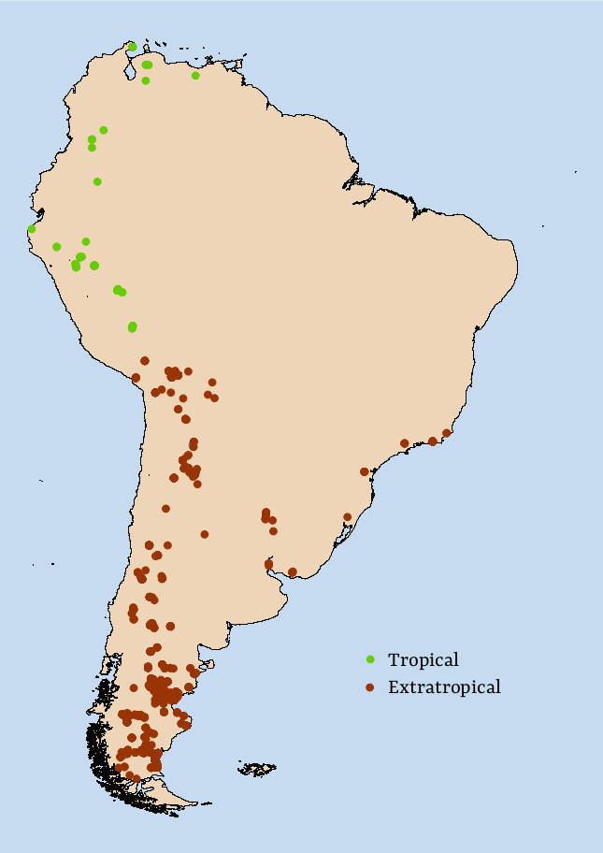

**Figure S3.** Map of the fossil-bearing localities considered in this study (435 collections).These collections comprise a total of 3384 retained occurrences, including 156 of palaeotropical affinity (in green, 43 collections) and 3326 of extra-palaeotropical affinity (in brown, 391 collections).

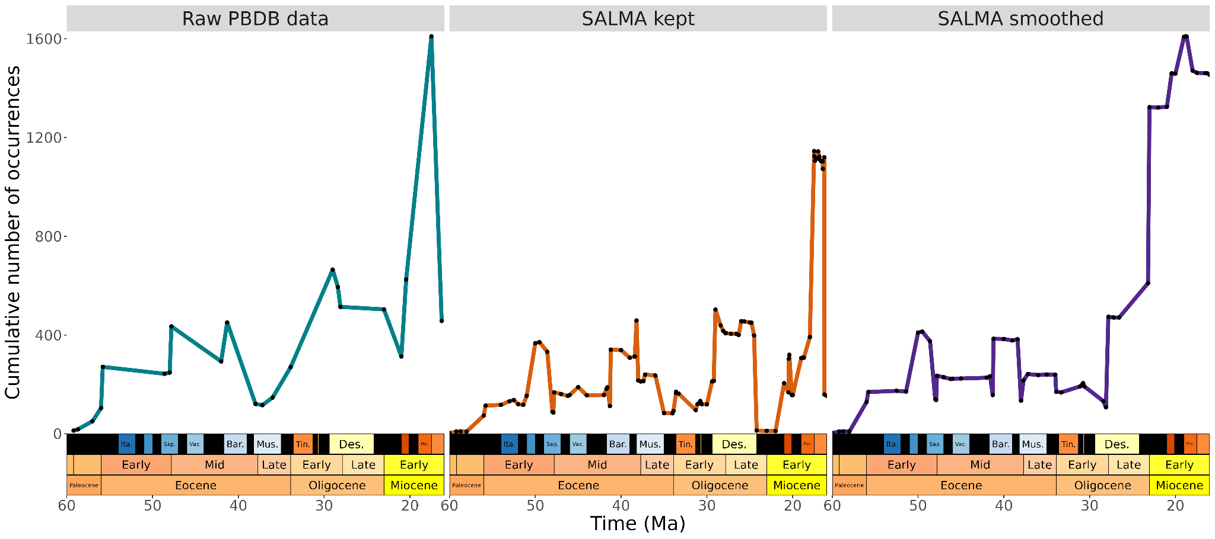

**Figure S4.** Cumulative number of occurrences through time within our study period**.** The cumulative number of occurrences is computed forward in time, starting from the lower age boundary of the oldest occurrence. Given a time t1, this metric grows by the difference between the number of occurrences having t1 as lower and upper boundaries. In practice, the times when this metric was computed are represented by the black dots. On the left, results from the raw data downloaded from PBDB are shown. In the middle, results from cleaned occurrences are shown. On the right, results from the same cleaned data but after smoothing occurrences associated to a South American Land Mammal Age (SALMA) to their corresponding sub-epoch (see **Fig. S1**) are shown.

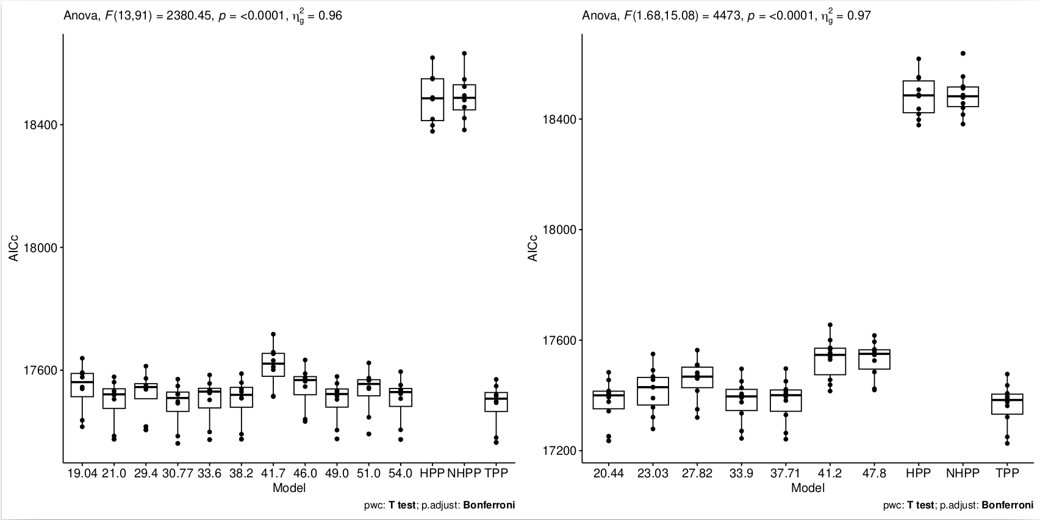

**Figure S5.** Preservation model selection under two TPP scenarios applied to the genus dataset with smoothed SALMAs**.** Models on the left of the x axis indexed by numbers are TPP with one removed bin, corresponding to the number. In the three cases, the lowest AICc is reached with the TPP model. Results were obtained on 10 replicates. **(A)** TPP with rate shift at every South American Land Mammal Age (SALMA) (mean AICc for TPP : 17486.42). **(B)** TPP with rate shift at every stage (mean AICc for TPP : 17364.53). Details for the AIC of all models can be found in Dataset S1.

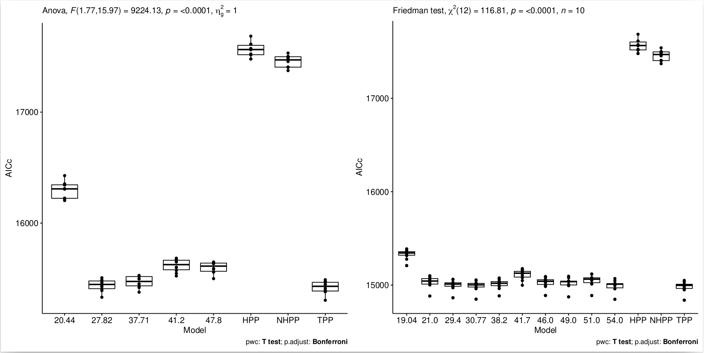

**Figure S6.** Preservation model selection under two TPP scenarios applied to the genus dataset without smoothing SALMAs**.** Models on the left of the x axis indexed by numbers are TPP with one removed bin, corresponding to the number. **(A)** TPP with rate shift at every stage (mean AICc for TPP : 15420.42). **(B)** TPP with rate shift at every SALMA (mean AICc for TPP : **XXX**). Details for the AIC of all models can be found in Dataset S1.

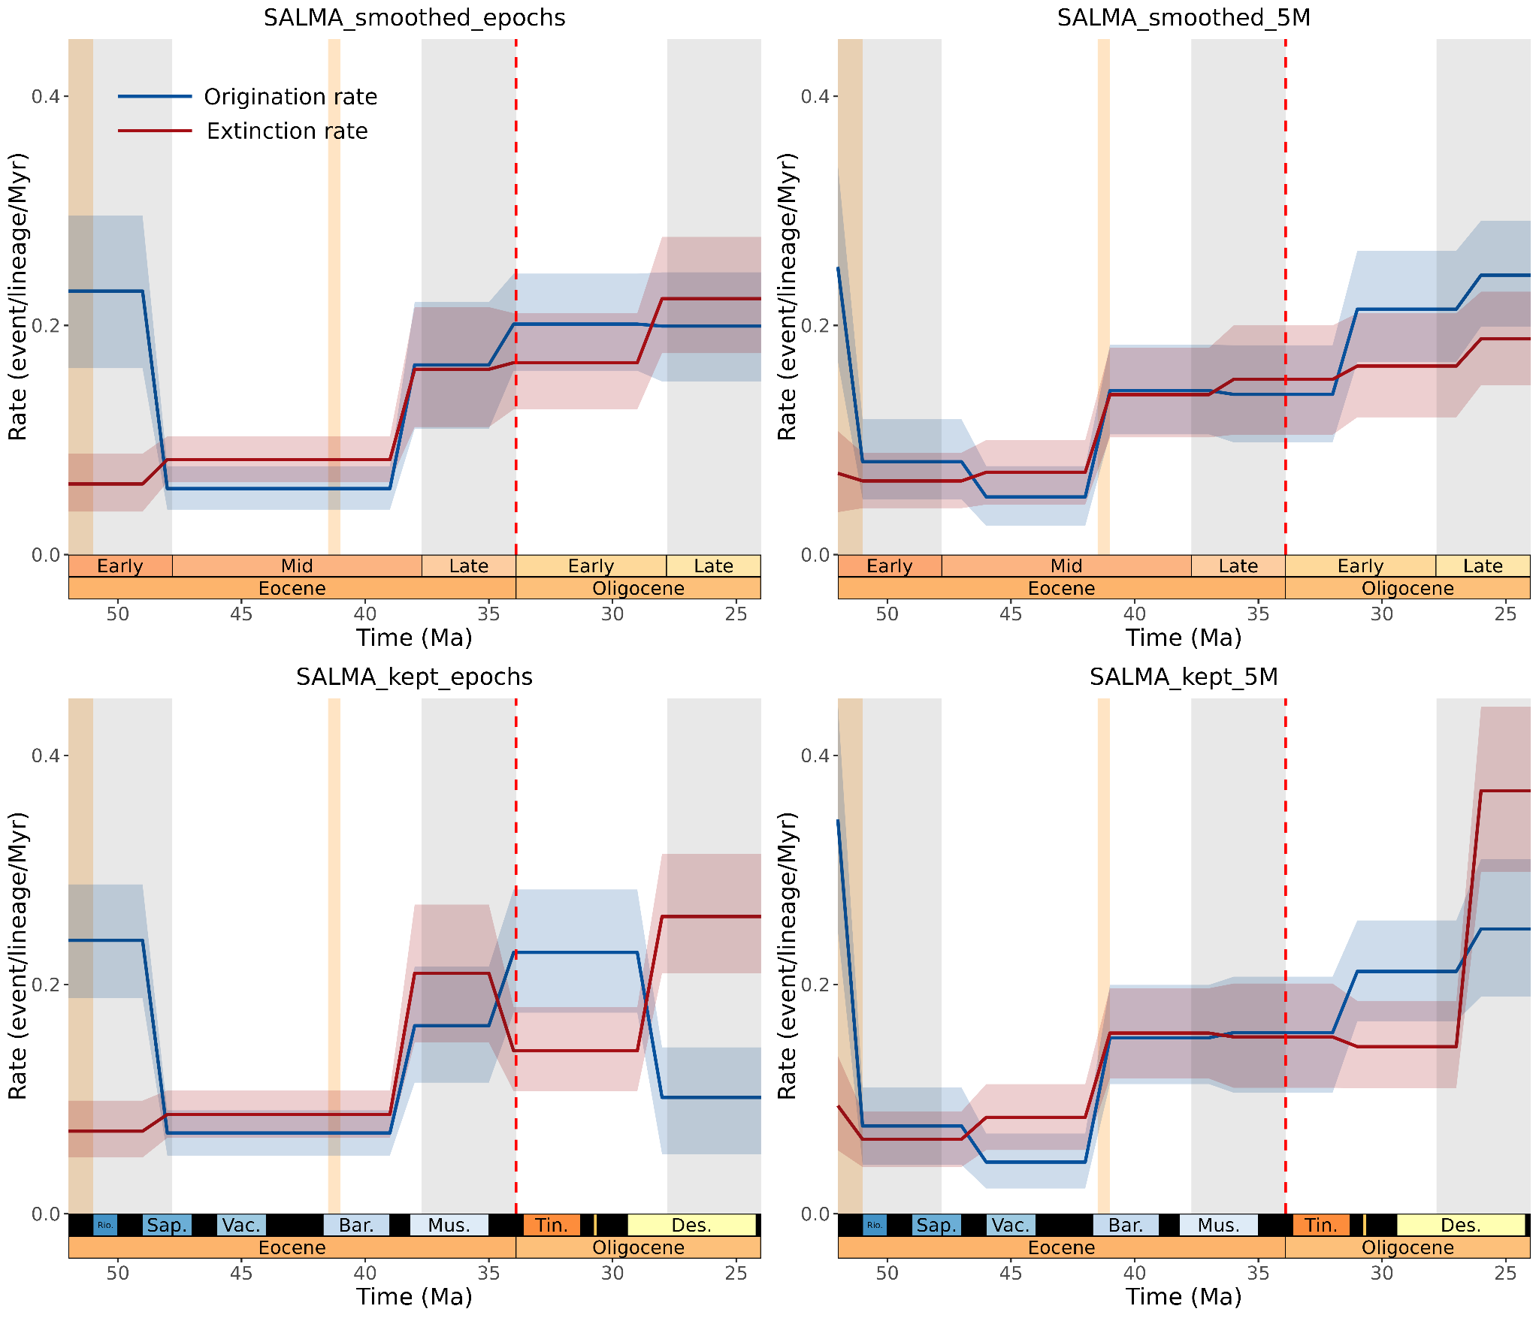

**Figure S7.** Diversification rates of our full dataset after (or not) smoothing SALMAs to their corresponding sub-Epochs, estimated under the BDCS model with two different time bins for rate shifts.Origination rates are displayed in blue and extinction rates in red. Solid lines show average rates, and shaded areas their corresponding 95% HPD. Light brown vertical bands respectively display the Early Eocene Climate Optimum (EECO, 53-51 Ma) and the Mid-Eocene Climate Optimum (MECO, 42-41 Ma)

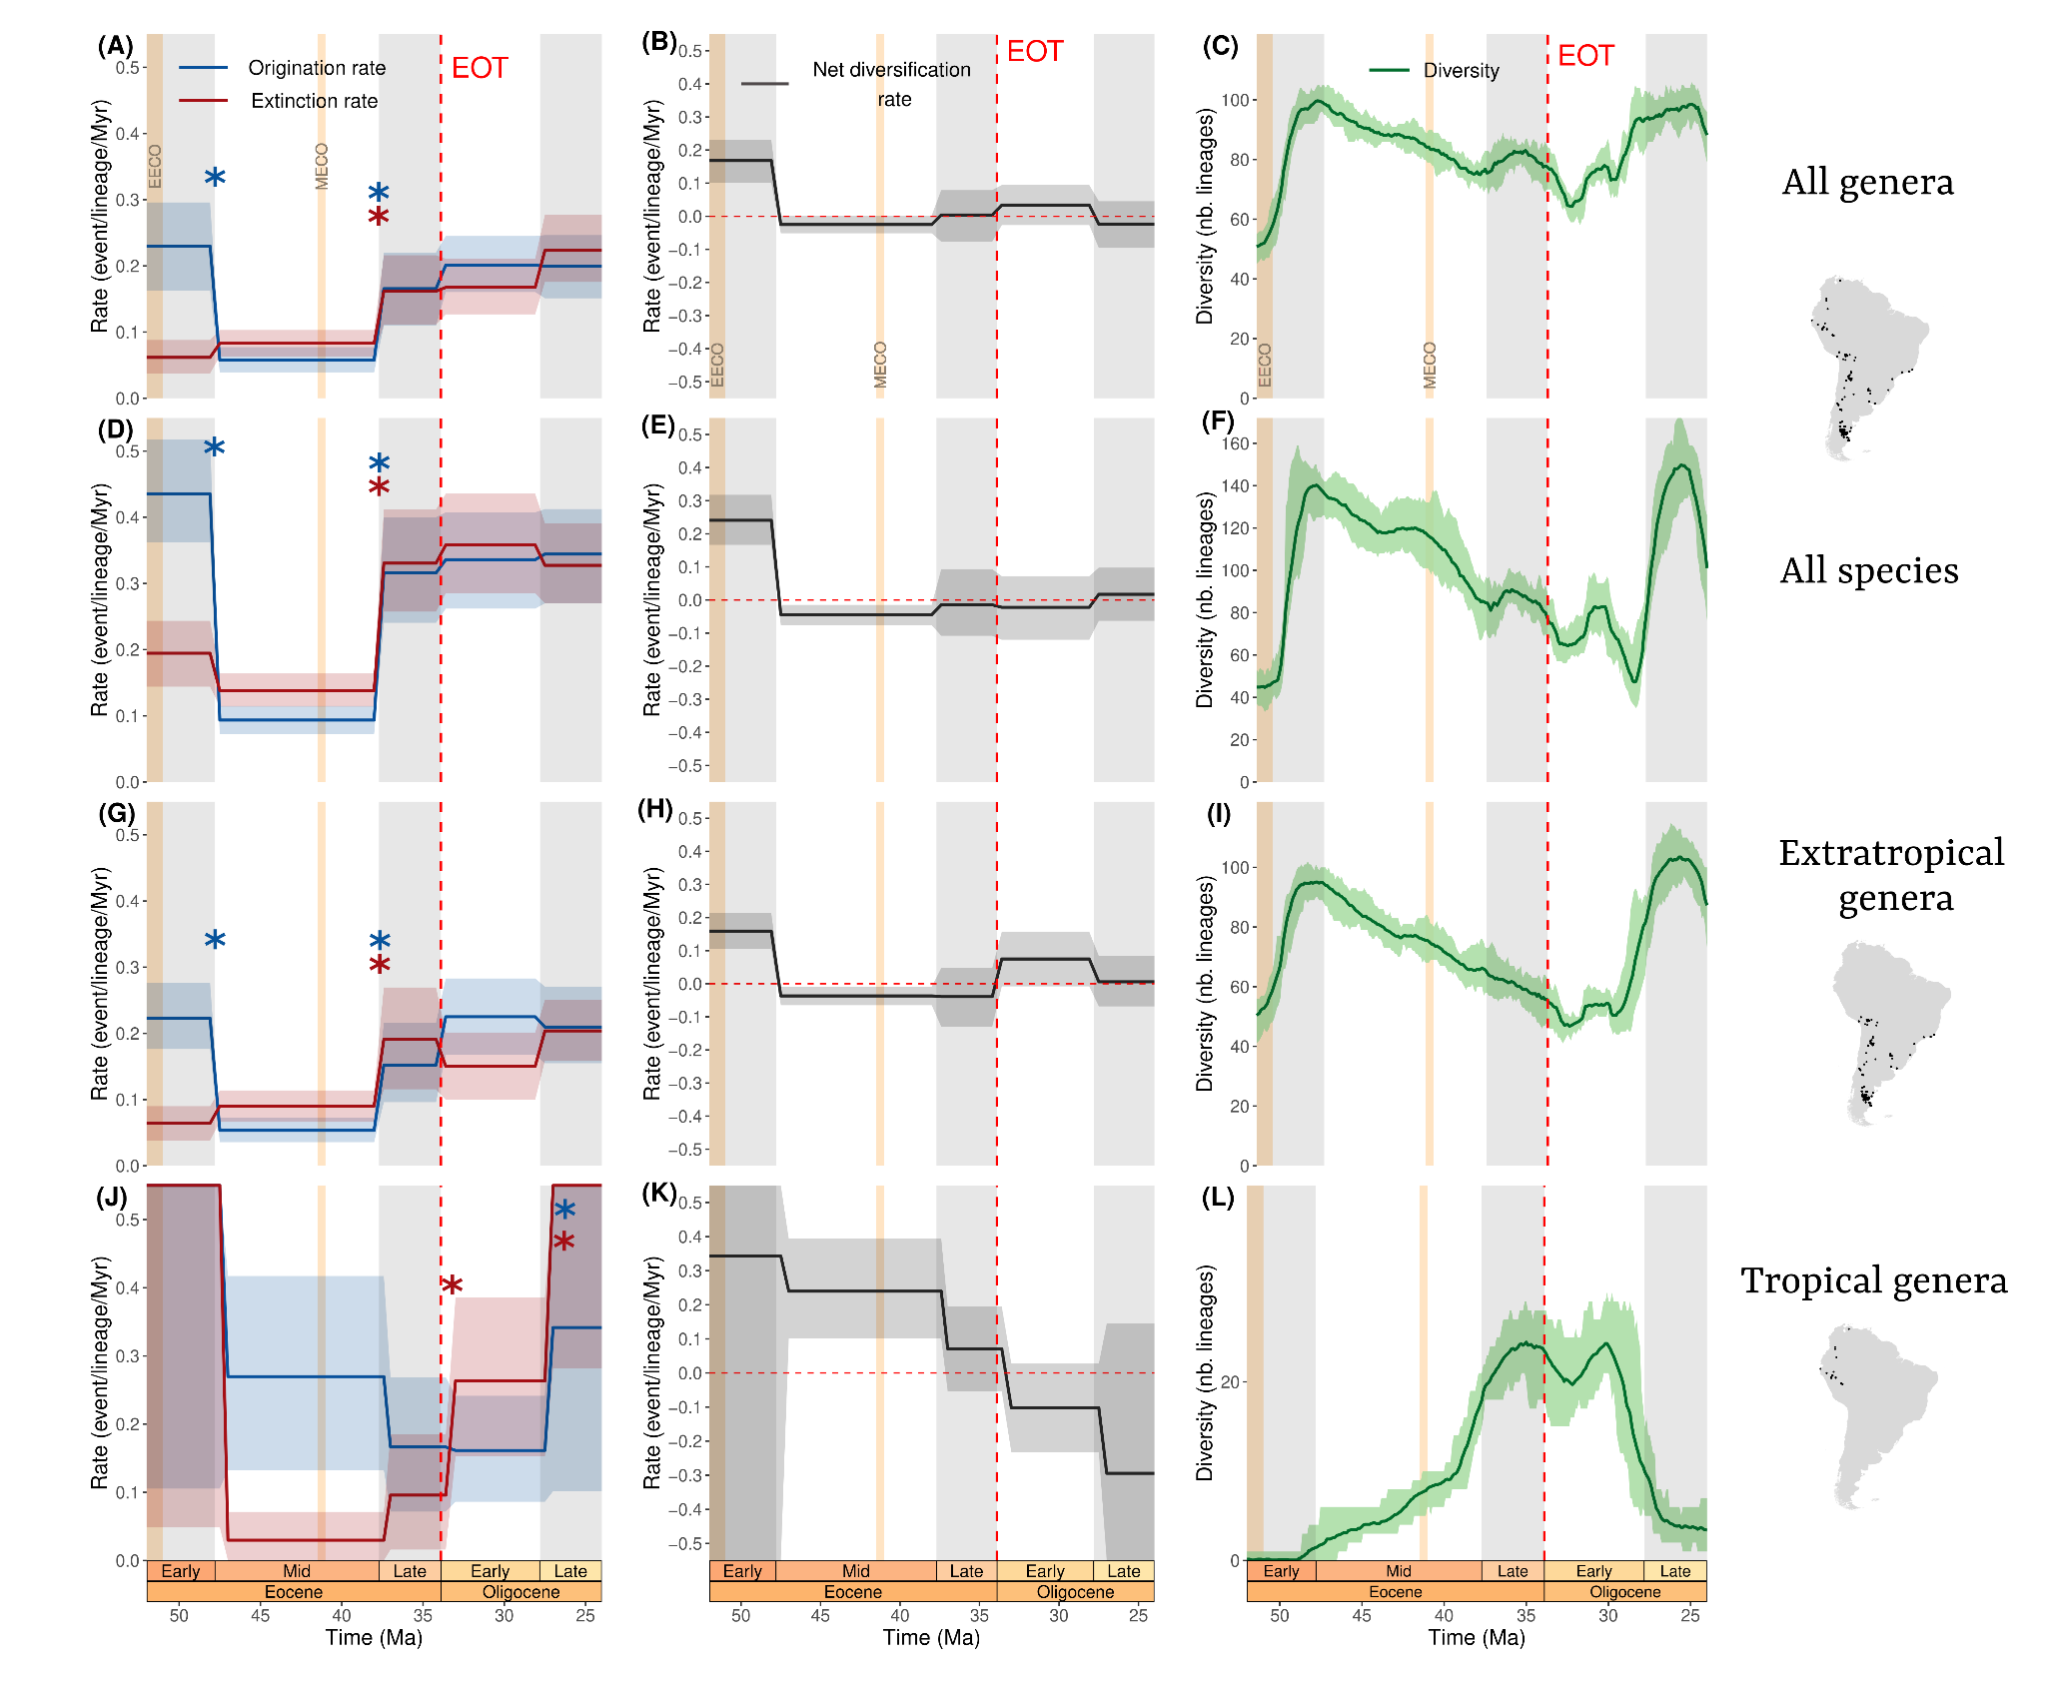

**Figure S8.** Diversification and diversity dynamics of South American Mammals from the Early Eocene to the Late Oligocene. Trends are represented for all genera (**A-C**), all species (**D-F**), extratropical (**G-I**) and tropical genera (**J-L**). Light orange bands represent the Early Eocene (53-51 Ma) and the Mid-Eocene (~41 Ma) Climate Optima, respectively abbreviated as EECO and MECO. Blue and red stars respectively represent significant shifts in origination and extinction rates. Geological timescale was depicted using the *deeptime* R package [(Gearty 2023)](https://www.zotero.org/google-docs/?vfqcST)*.*

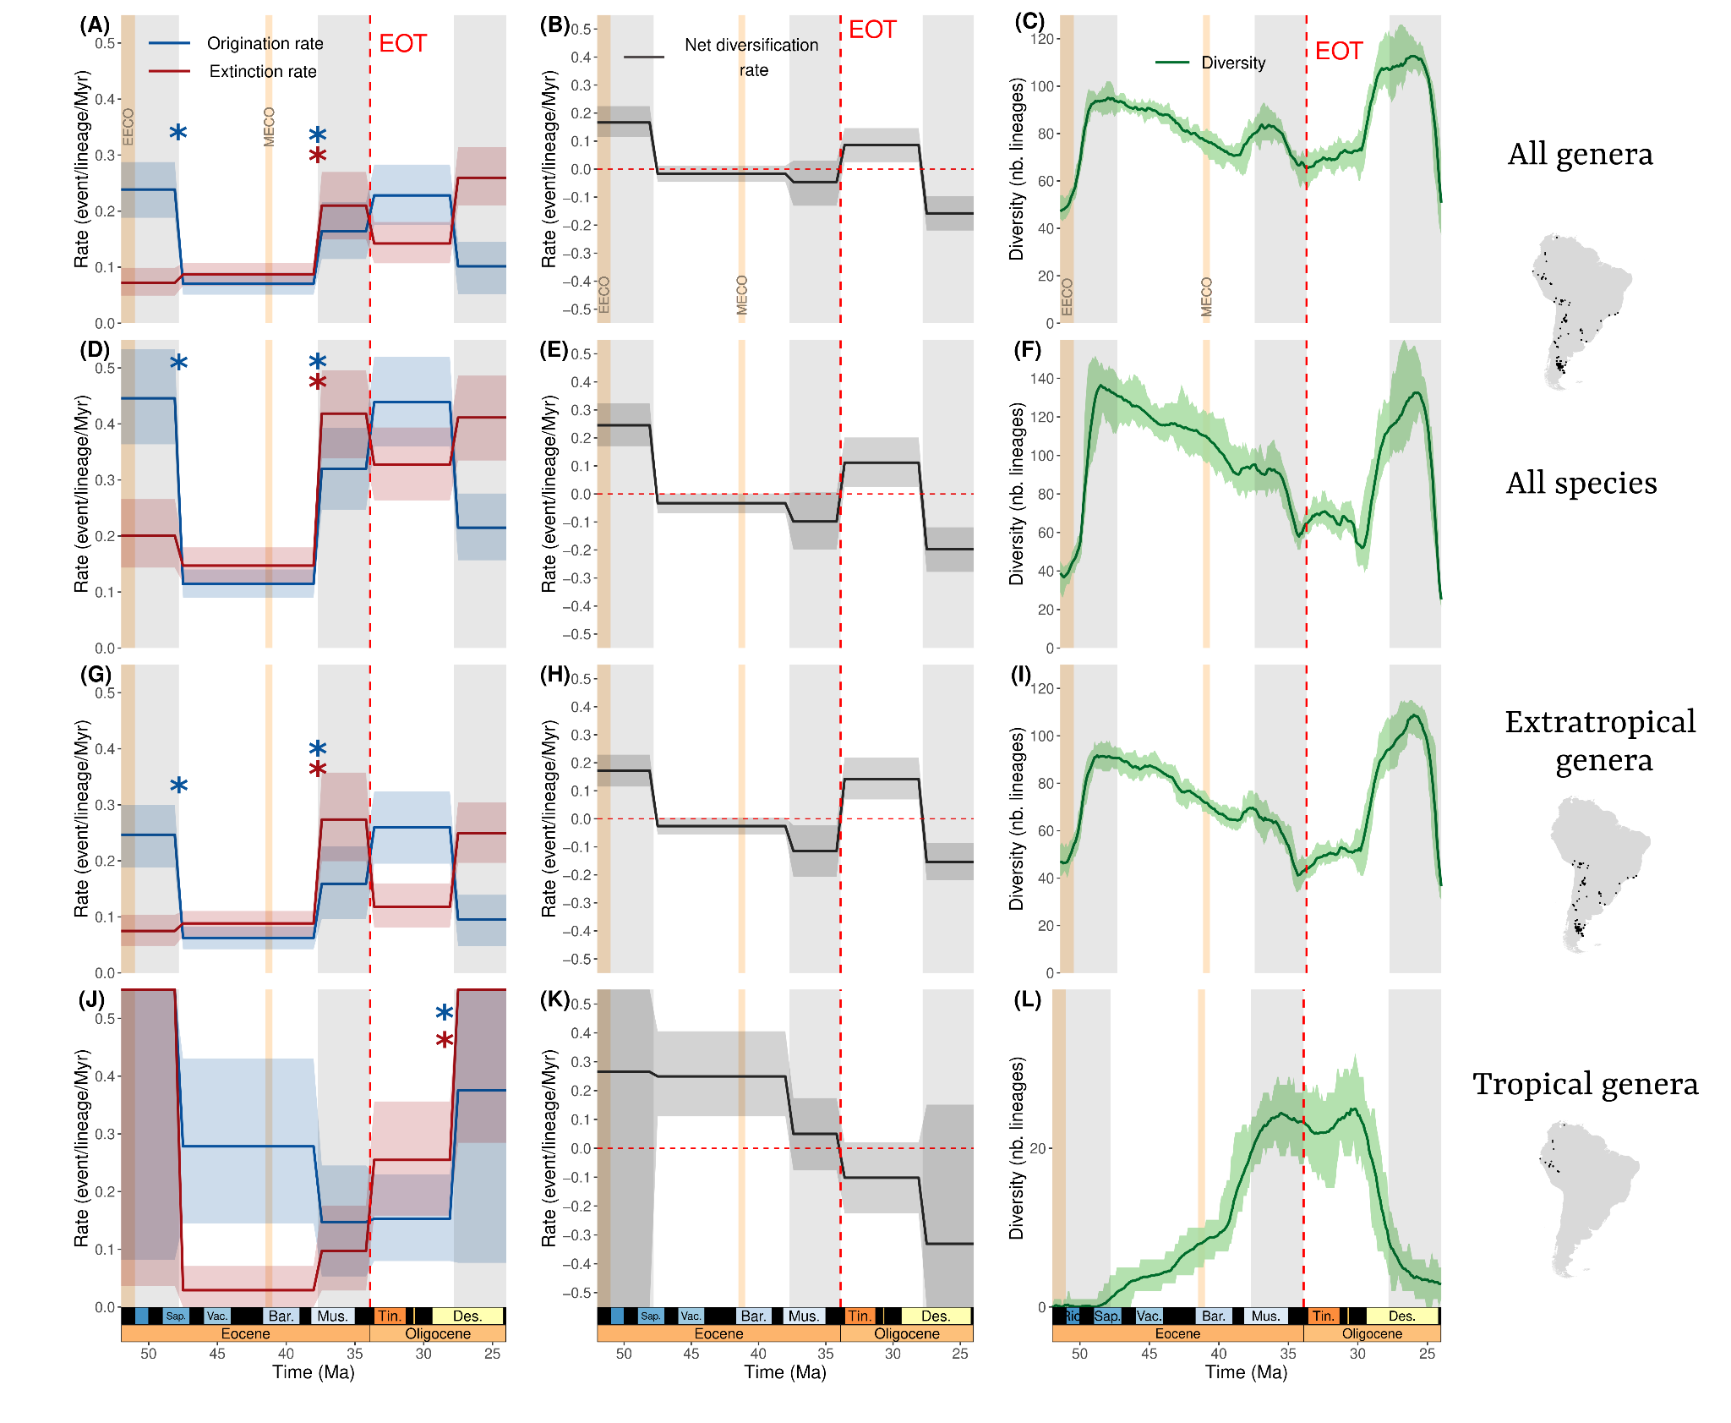

**Figure S9.** Diversification and diversity dynamics of South American Mammals from the Early Eocene to the Late Oligocene without binning SALMAs to their corresponding sub-epochs.Trends are represented for all genera (**A-C**), all species (**D-F**), extratropical (**G-I**) and tropical genera (**J-L**). Light orange bands represent the Early Eocene (53-51 Ma) and the Mid-Eocene (~41 Ma) Climate Optima, respectively abbreviated as EECO and MECO. Blue and red stars respectively represent significant shifts in origination and extinction rates. Geological timescale was depicted using the *deeptime* R package [(Gearty 2023)](https://www.zotero.org/google-docs/?39hURh)*.*

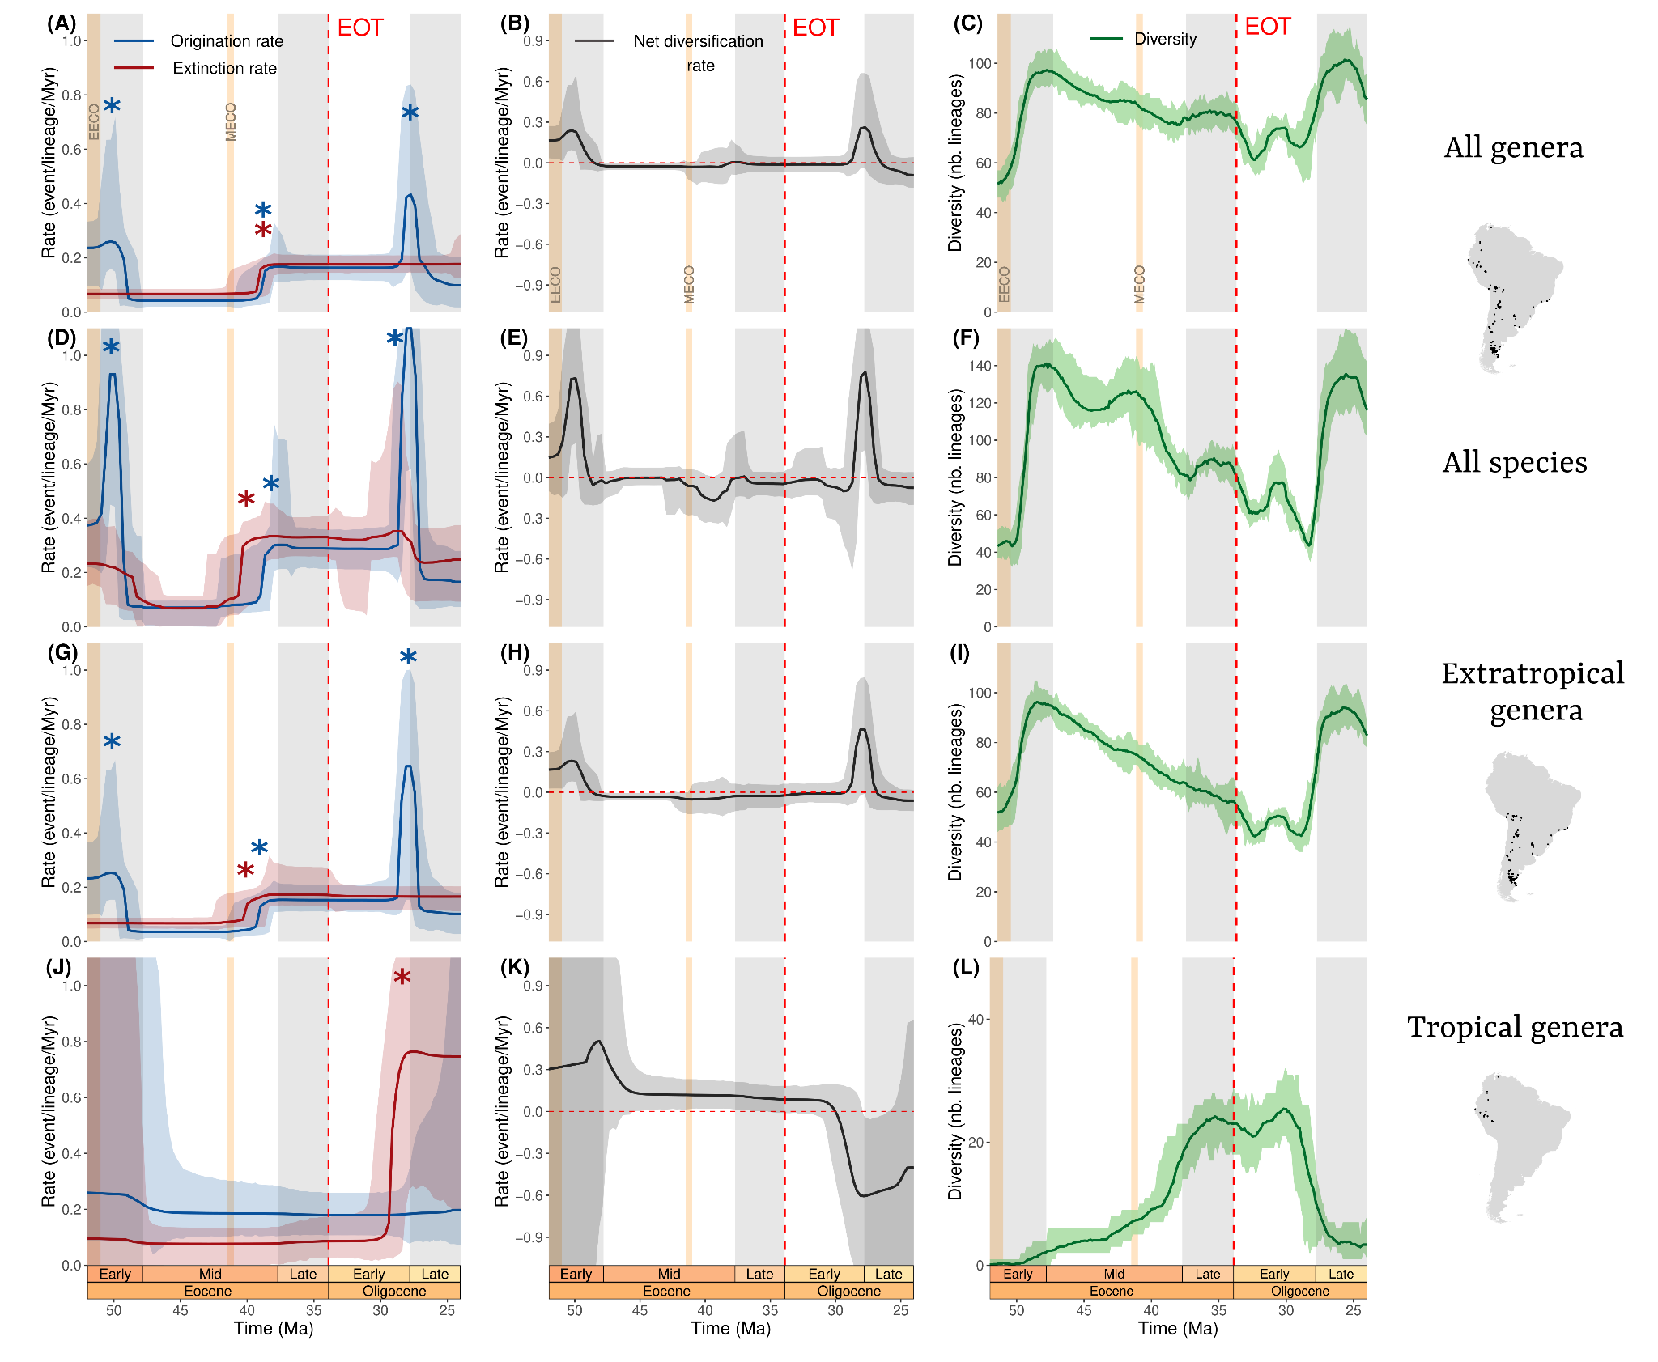**Figure S10.** Diversification (estimated with RJMCMC) and diversity dynamics of South American Mammals from the Early Eocene to the Late Oligocene (SALMAs binned to their corresponding Sub-Epochs).Trends are represented for all genera (**A-C**), all species (**D-F**), extratropical (**G-I**) and tropical genera (**J-L**). Light orange bands represent the Early Eocene (53-51 Ma) and the Mid-Eocene (~41 Ma) Climate Optima, respectively abbreviated as EECO and MECO. Blue and red stars respectively represent significant shifts in origination and extinction rates. Geological timescale was depicted using the *deeptime* R package [(Gearty 2023)](https://www.zotero.org/google-docs/?Wd3ocV)*.*

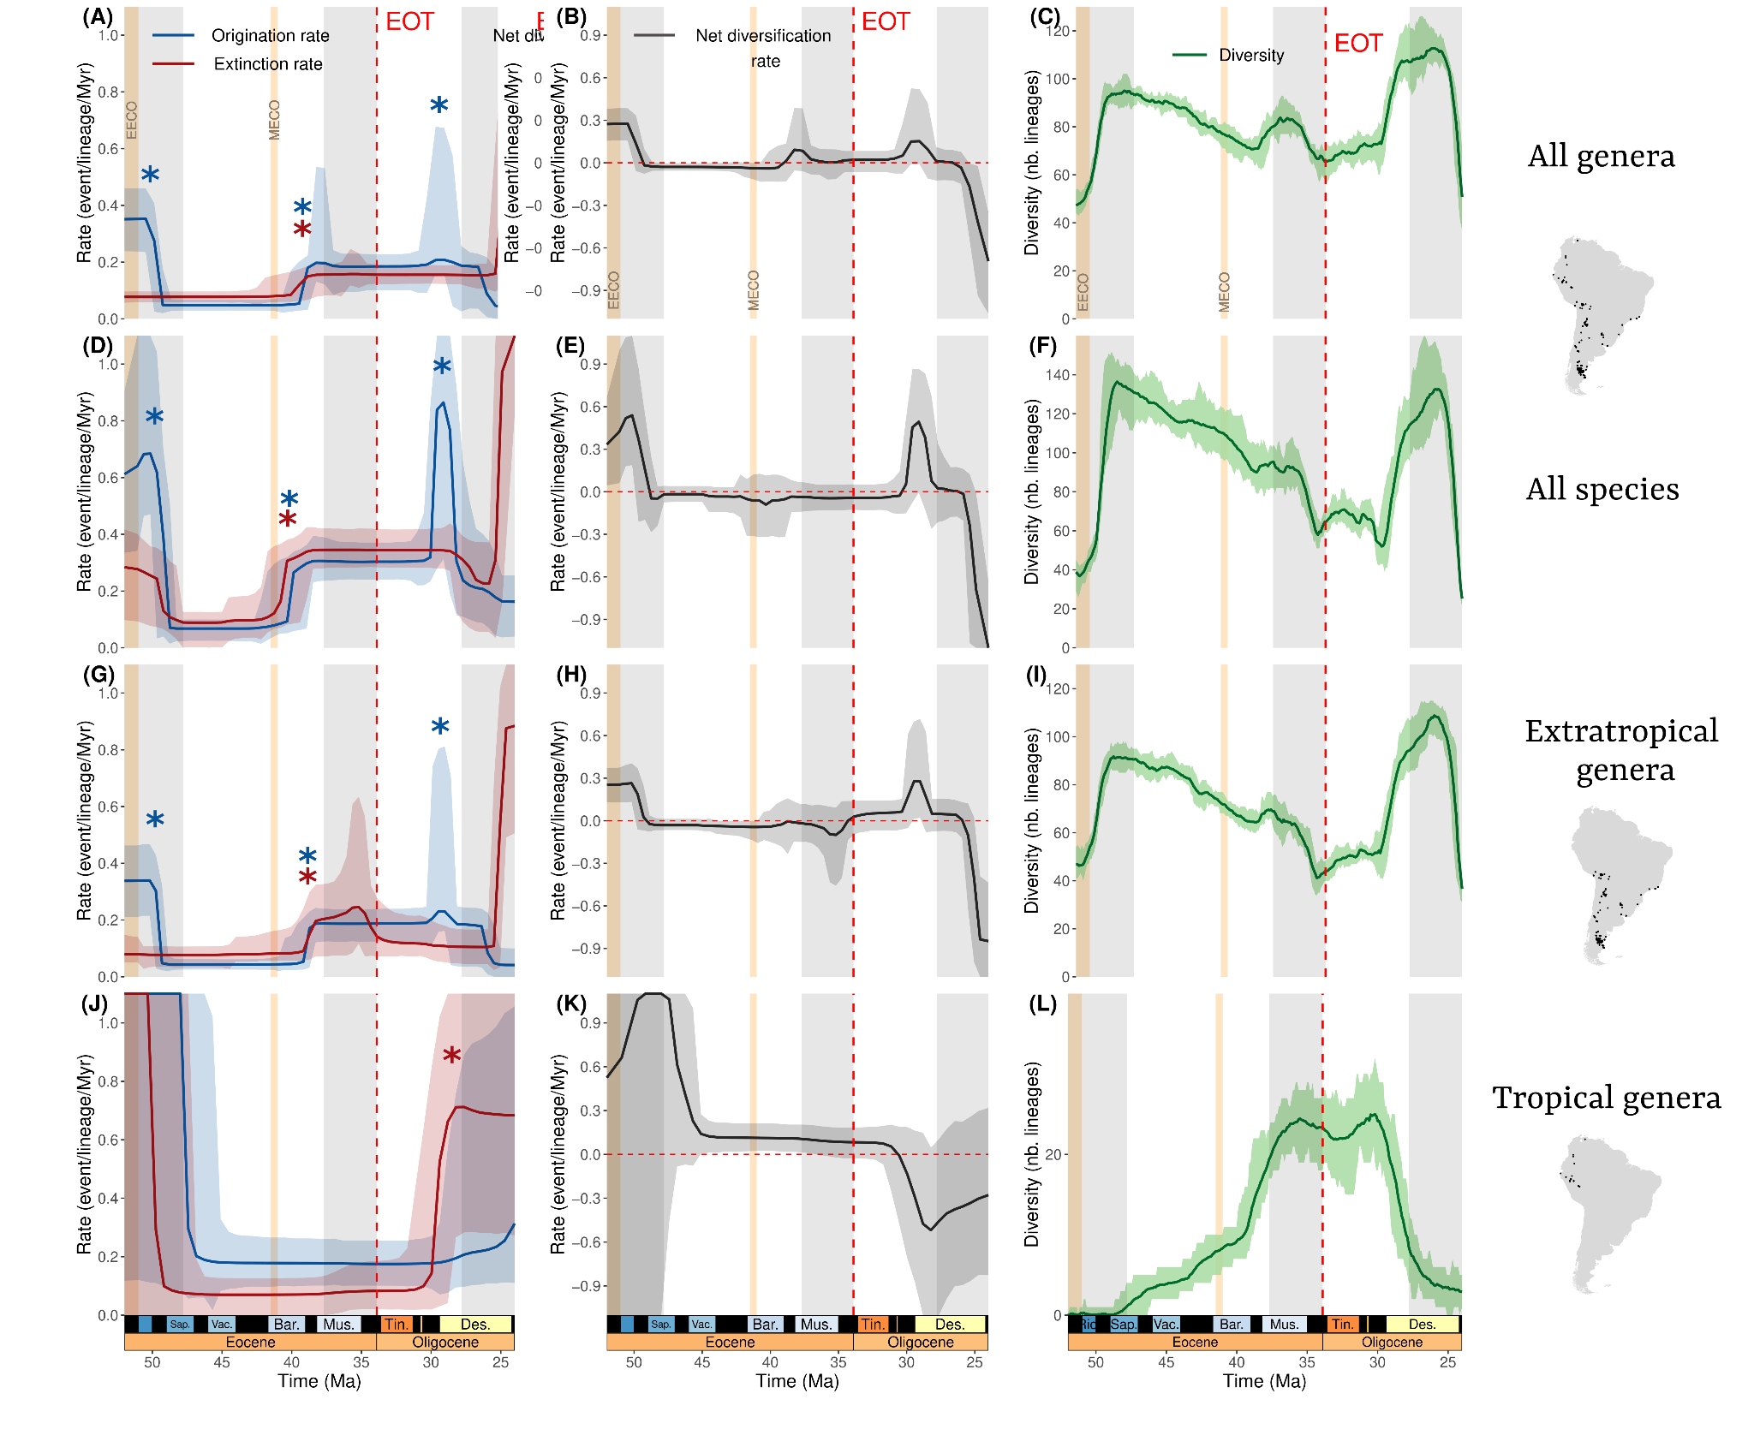

**Figure S11.** Diversification (estimated with RJMCMC) and diversity dynamics of South American Mammals from the Early Eocene to the Late Oligocene (without binning SALMAs to their corresponding Sub-Epochs).Trends are represented for all genera (**A-C**), all species (**D-F**), extratropical (**G-I**) and tropical genera (**J-L**). Light orange bands represent the Early Eocene (53-51 Ma) and the Mid-Eocene (~41 Ma) Climate Optima, respectively abbreviated as EECO and MECO. Blue and red stars respectively represent significant shifts in origination and extinction rates. Geological timescale was depicted using the *deeptime* R package [(Gearty 2023)](https://www.zotero.org/google-docs/?KF8eQa)*.*

**Figure S12.** Diversification and diversity dynamics of South American Mammals from the Early Eocene to the Late Oligocene after removing singletons.

**Figure S13.** Diversification (estimated with RJMCMC) and diversity dynamics of South American Mammals from the Early Eocene to the Late Oligocene after removing singletons

**Figure S14.** Diversification and diversity dynamics of South American Mammals from the Early Eocene to the Late Oligocene after subsetting our dataset to unique locality-lineage combinations.

**Figure S15.** Diversification (estimated with RJMCMC) and diversity dynamics of South American Mammals from the Early Eocene to the Late Oligocene after subsetting our dataset to unique locality-lineage combinations.

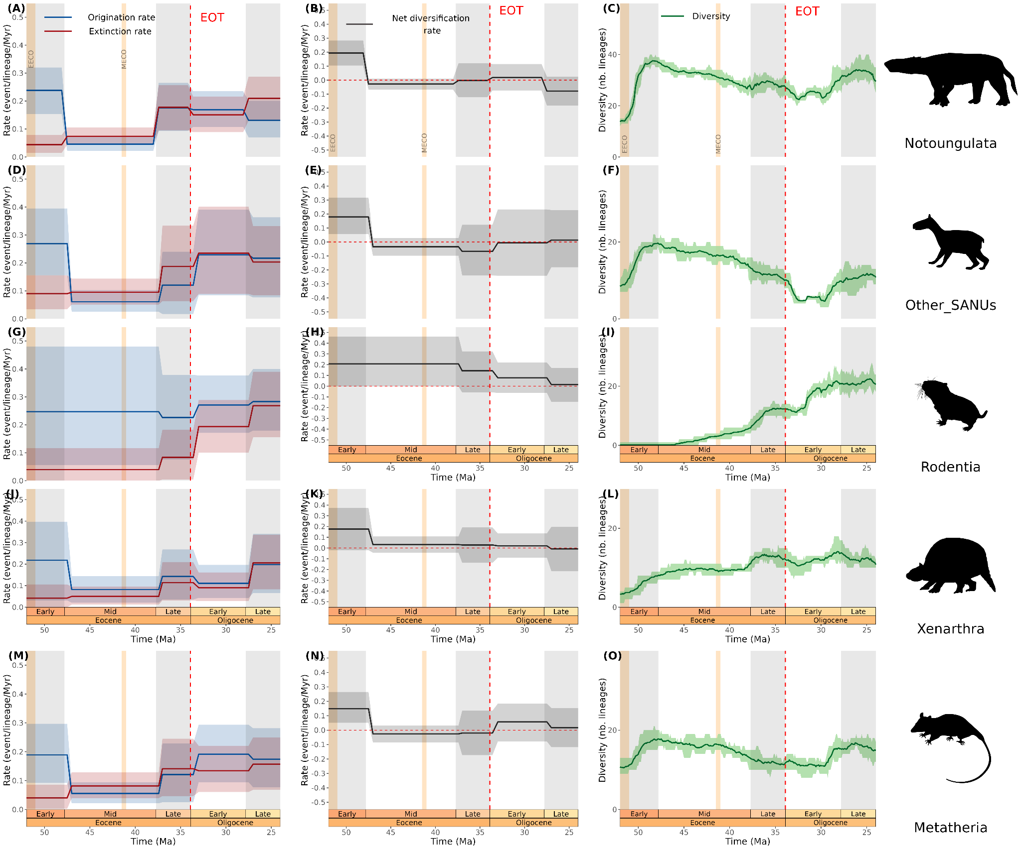

**Figure S16.** Genus-level diversity and diversification dynamics of five mammal groups from the Early Eocene to the Late Oligocene.Diversification trends are analysed under the BDCS algorithm using the origination and extinction times inferred by the analysis of the full dataset.Trends are represented for notoungulates (**A-C**), all the other native ungulates (“Other_SANUs”, i.e. Litopterna, Astrapotheria, Pyrotheria, Xenungulata) (**D-F**), rodents (**G-I**), xenarthrans (**J-L**) and metatherians (**M-O**). Light orange bands represent the Early Eocene (53-51 Ma) and the Mid-Eocene (~41 Ma) Climate Optima, respectively abbreviated EECO and MECO. Geological timescale was depicted thanks to the *deeptime* R package [(Gearty 2023)](https://www.zotero.org/google-docs/?Fzh0Xx)*.* Mammal silhouettes were added thanks to the *rphylopic* R package [(Gearty and Jones 2023)](https://www.zotero.org/google-docs/?QITU37).

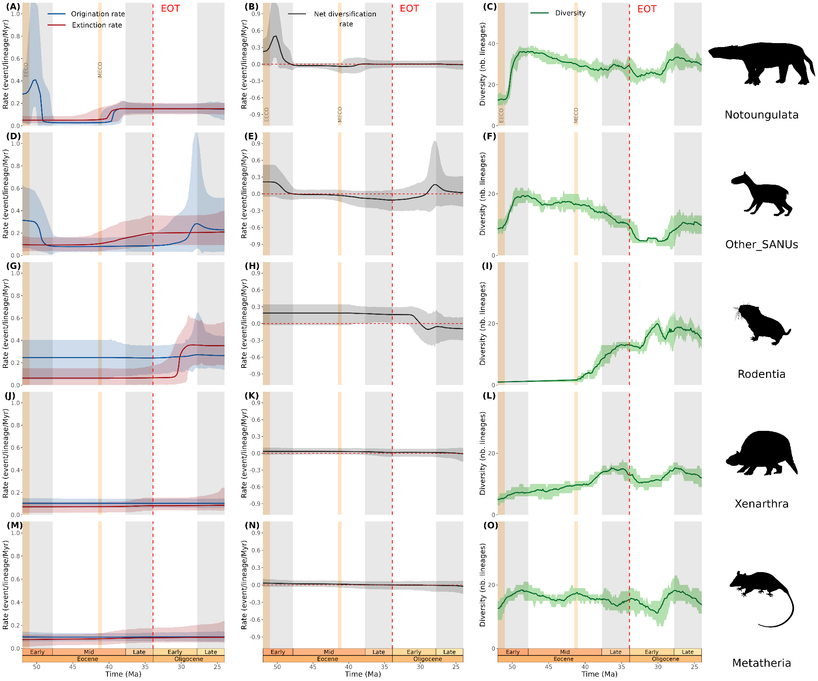

**Figure S17.** Genus-level diversity and diversification dynamics (inferred with RJMCMC) of five mammal groups from the Early Eocene to the Late Oligocene.Diversification trends are analysed under the RJMCMC algorithm (de-novo estimation of origination and extinction times). Trends are represented for notoungulates (**A-C**), all the other native ungulates (“Other_SANUs”, i.e. Litopterna, Astrapotheria, Pyrotheria, Xenungulata) (**D-F**), rodents (**G-I**), xenarthrans (**J-L**) and metatherians (**M-O**). Light orange bands represent the Early Eocene (53-51 Ma) and the Mid-Eocene (~41 Ma) Climate Optima, respectively abbreviated EECO and MECO. Geological timescale was depicted thanks to the *deeptime* R package [(Gearty 2023)](https://www.zotero.org/google-docs/?4ZMGL2)*.* Mammal silhouettes were added thanks to the *rphylopic* R package [(Gearty and Jones 2023)](https://www.zotero.org/google-docs/?Vgpg7i).

Herbivores show an increasing turnover from late Eocene onwards (**Fig. X**). This goes in line with the literature, where both high and low-latitude localities document shift from brachyodont Eocene native ungulate faunas (main herbivore compounds of the studied palaeo-mammalian assemblages, **Tab. S1**) to hypsodont ones in the Oligocene [(6, 7)](https://www.zotero.org/google-docs/?ocehmM)

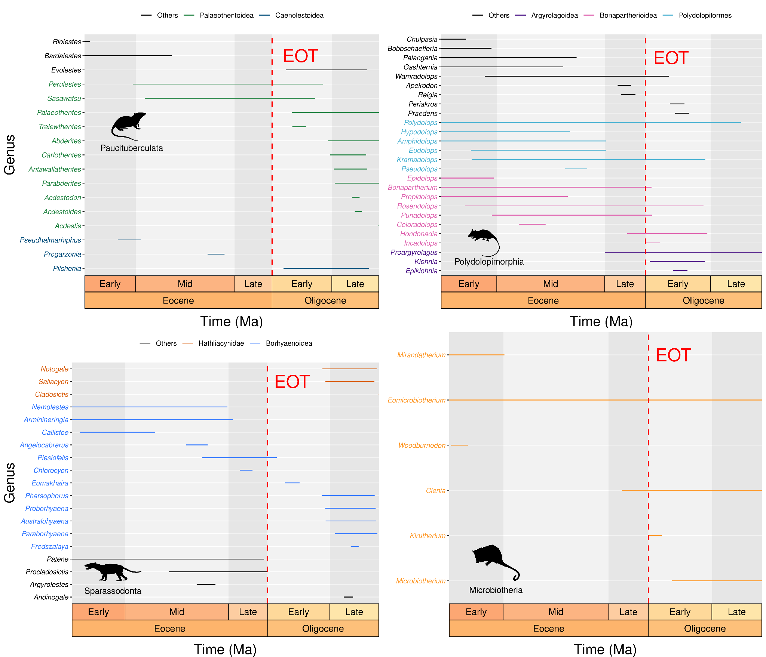

**Figure S18:** Metatherian genera longevity across the Eocene-Oligocene

Each panel represents a phylogenetic order, within which each genera are coloured based on their superfamily. Following [(8)](https://www.zotero.org/google-docs/?k7RmB6), we chose to nest the superfamily Argyrolagoidea inside Polydolopimorphia, but we know that this phylogenetic placement is under debate (see [(9)](https://www.zotero.org/google-docs/?NDgXB9)).

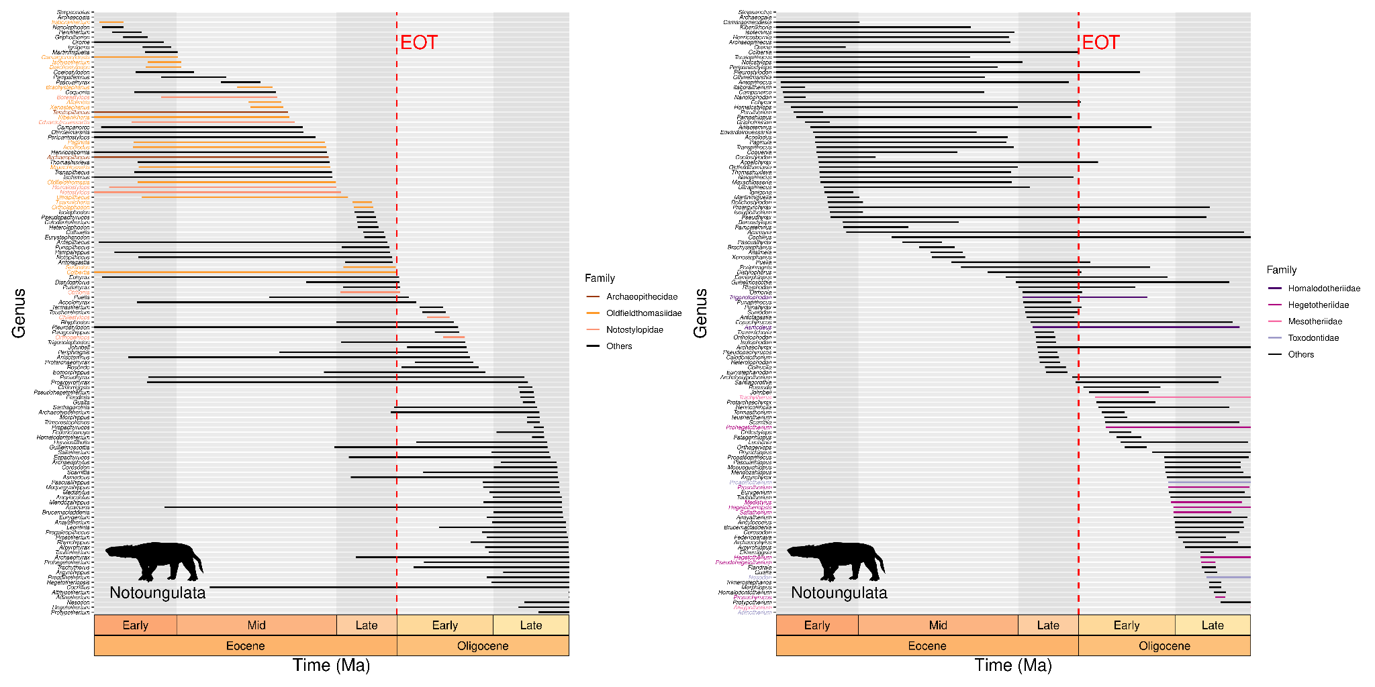

**Figure S19.** Notoungulate genera longevity across the Eocene-Oligocene.Both plots display the exact same information. On the left panel, genera were organised by increasing age of extinction, and we highlighted with colours members from three basal families going extinct near the EOT (Oldfieldthomasiidae, Archaeopithecidae and Notostylopidae). Conversely, on the right panel, genera were organised by increasing age of origination, and we highlighted with colours members of families originating near the EOT (Homalodotheriidae, Hegetotheriidae, Mesotheriidae, Toxodontidae).

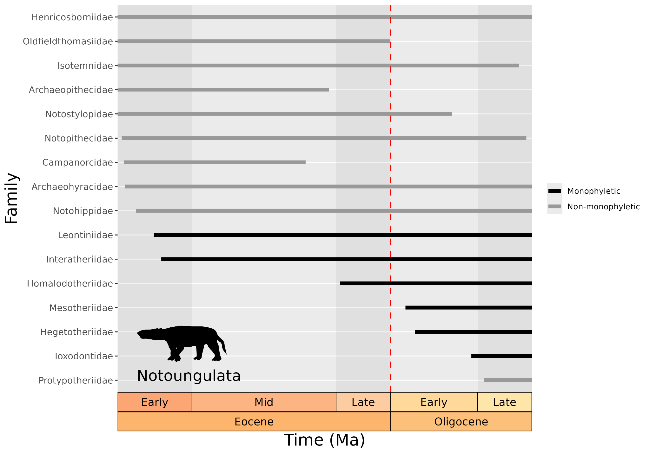**Figure S20.** Notoungulate families longevity across the Eocene-Oligocene. Monophyletic families are shown in black whereas non-monophyletic families are shown in grey. Information about each family’s monophyly was extracted from the phylogenetic reconstruction proposed by [(10)](https://www.zotero.org/google-docs/?0DMqT0).

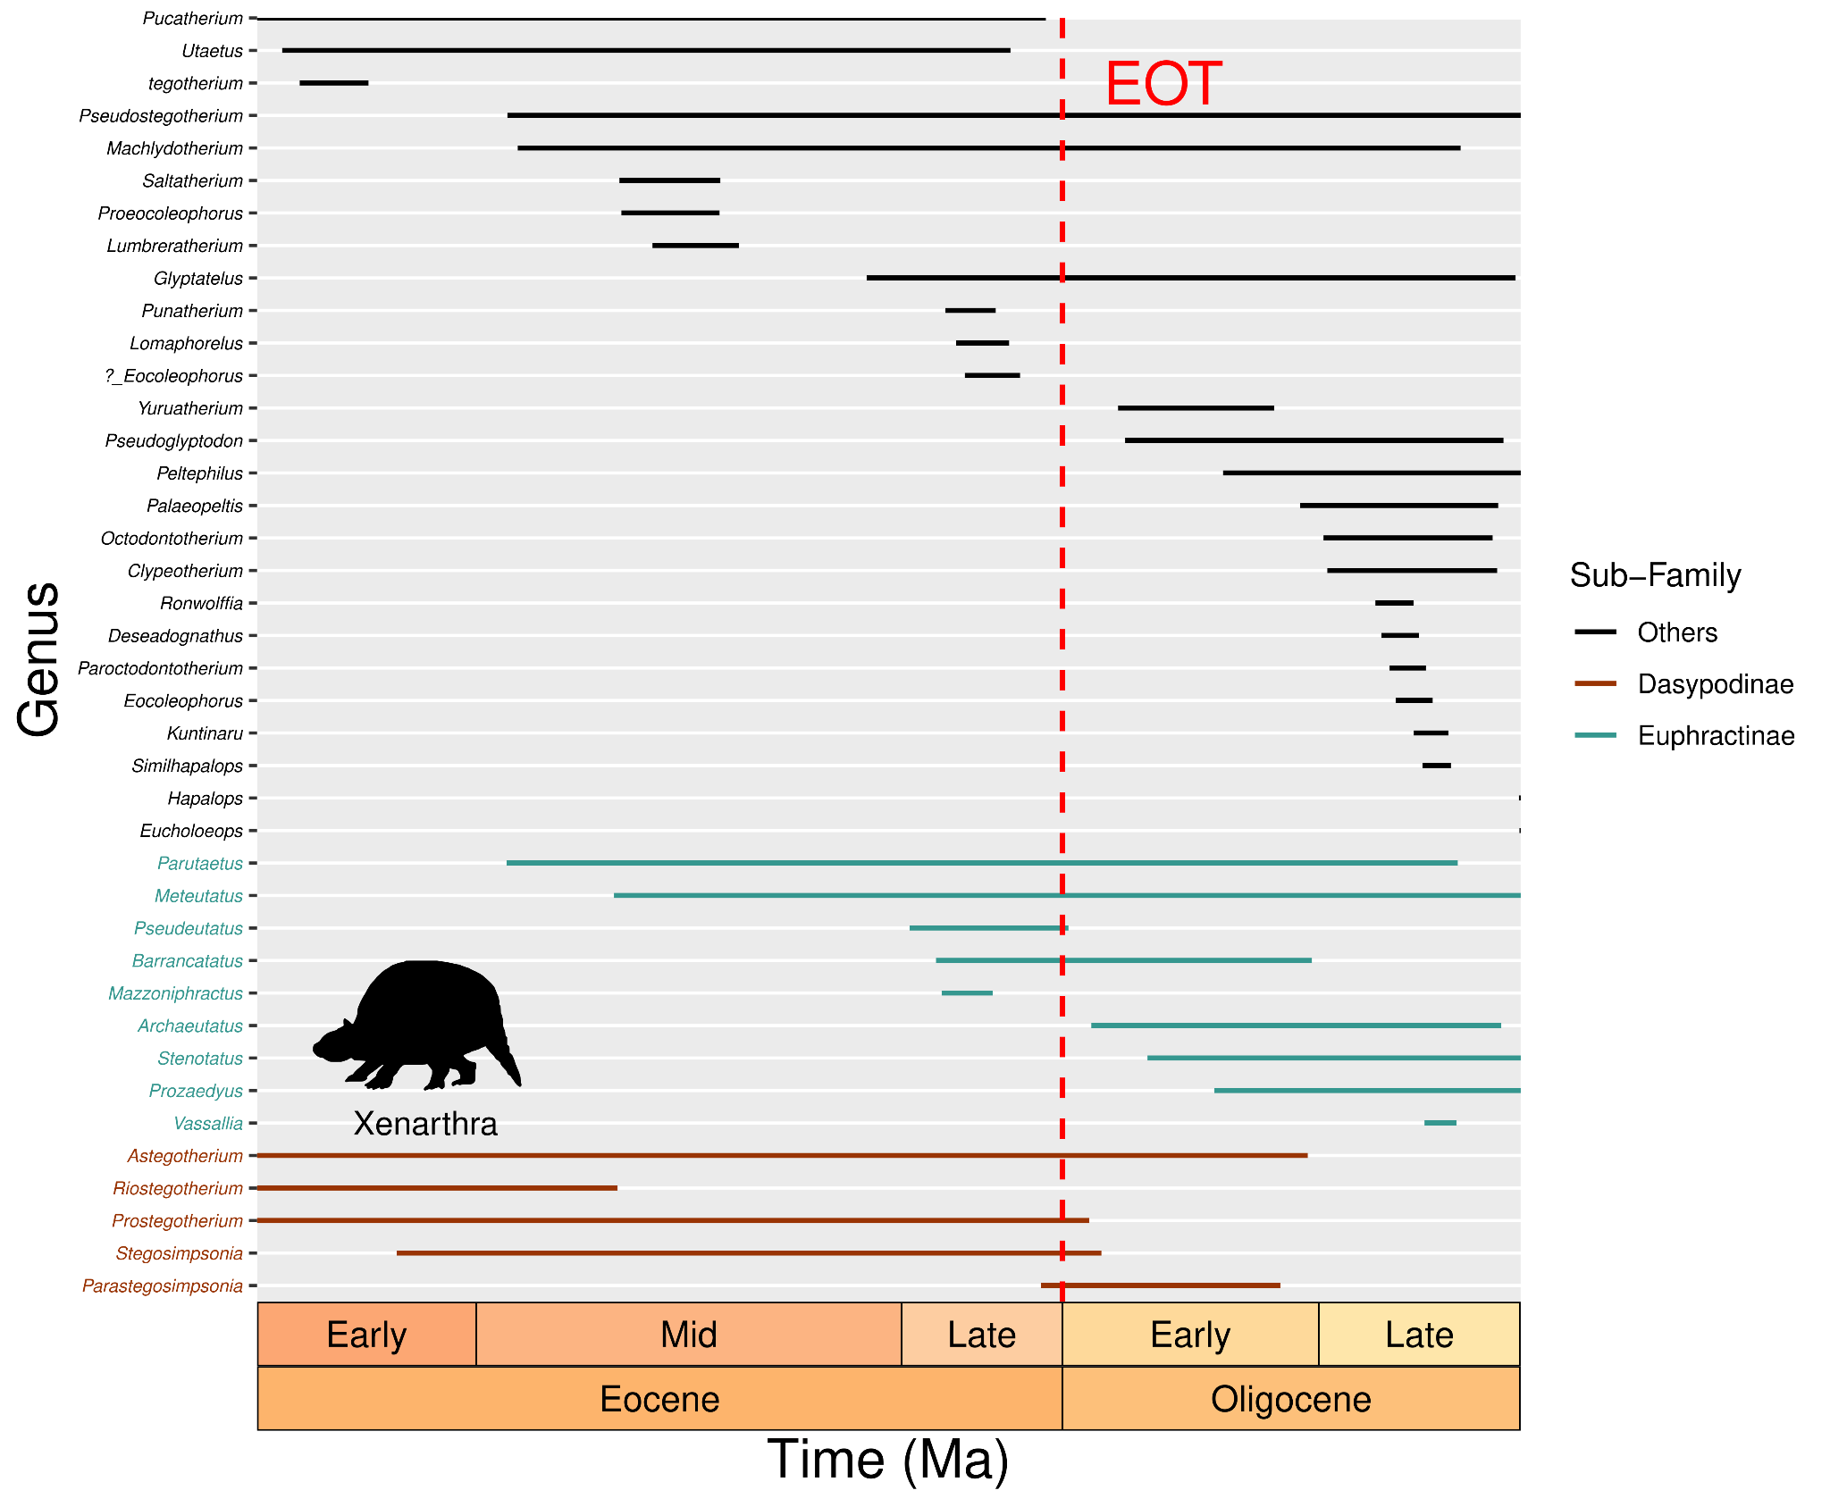

**Figure S21.** Xenarthran genera longevity across the Eocene-Oligocene. Genera were coloured based on their affinity with two cingulate subfamilies: Dasypodinae and Euphractinae.

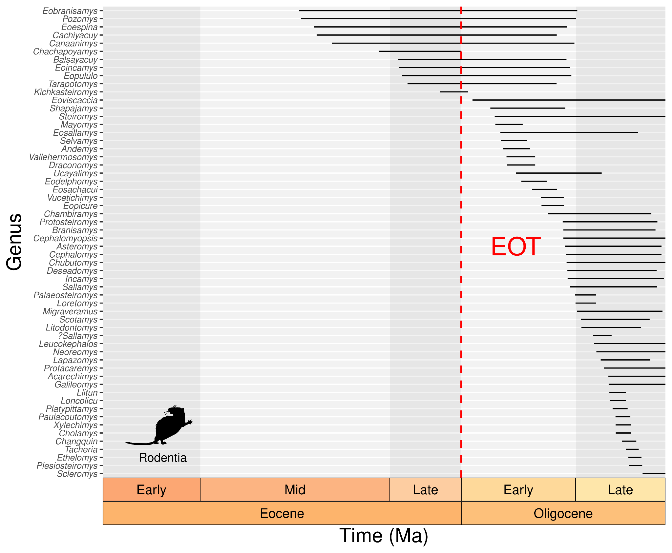

**Figure S22.** Rodent genera longevity across the Eocene-Oligocene.

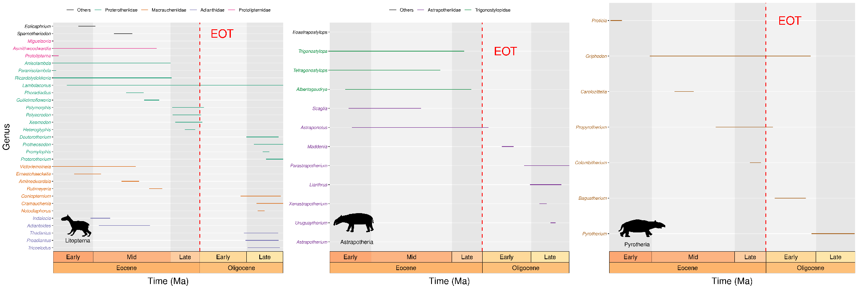

**Figure S23.** South American Native Ungulate genera longevity across the Eocene-Oligocene (without Notoungulata). Each panel represents a taxonomic order, within which genera are coloured based on their family.

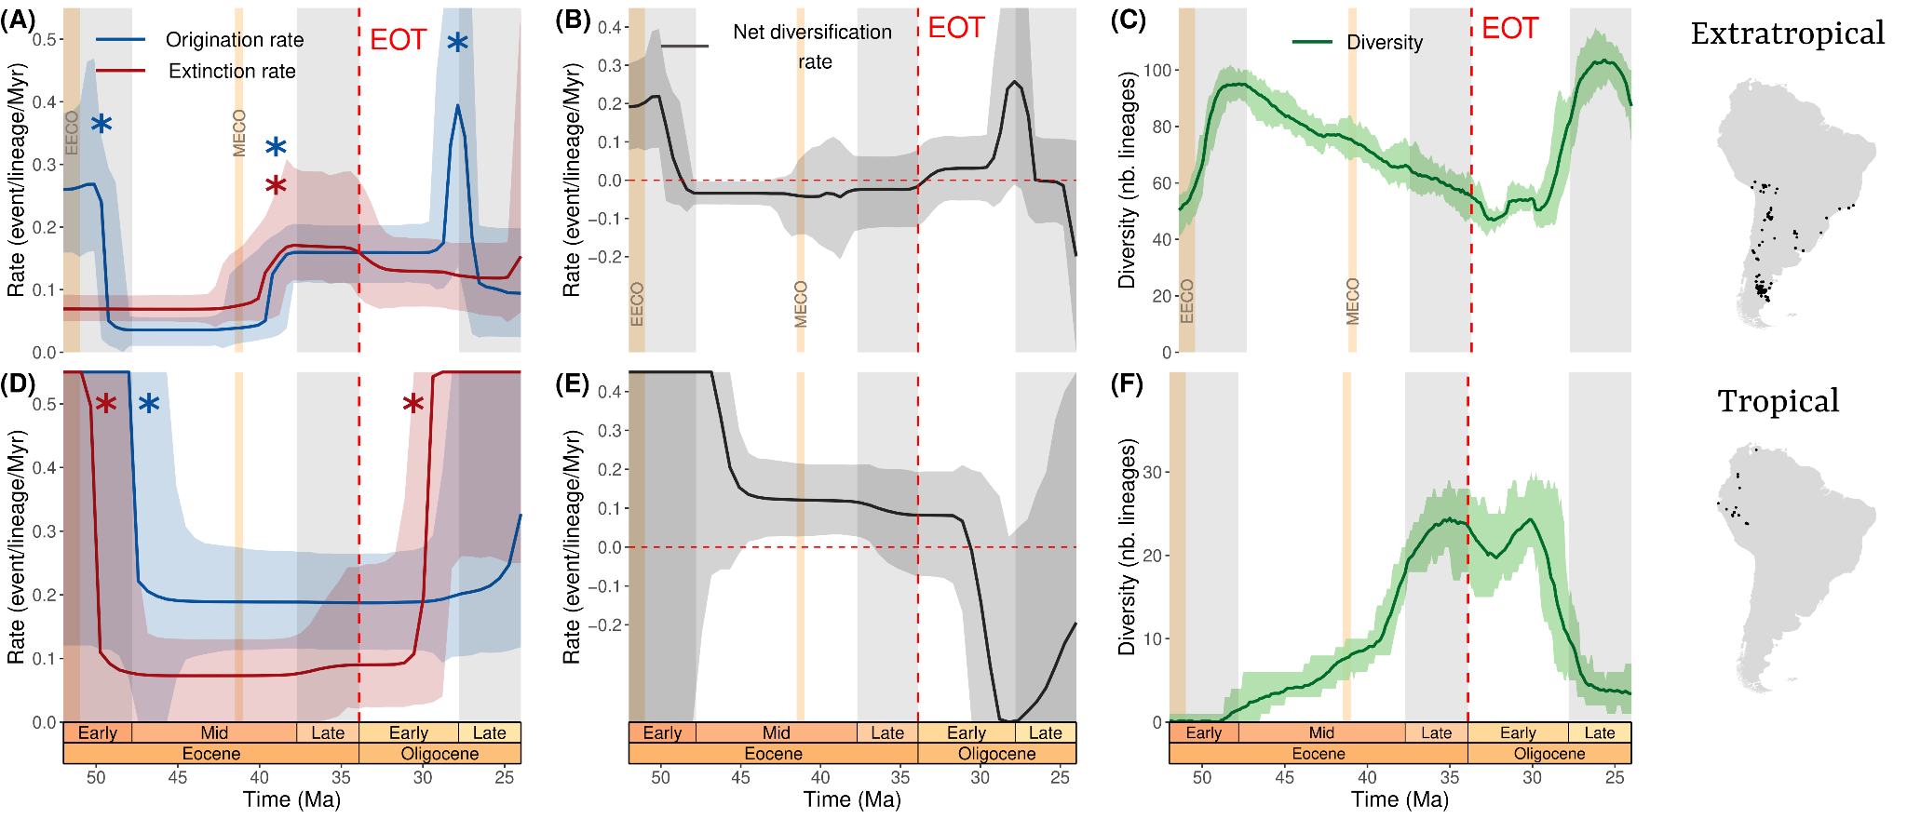

**Figure S24.** Diversity and diversification dynamics (inferred with RJMCMC) of South American mammal genera between the Eocene and the Oligocene arranged by latitude. Trends are assessed for the extratropical (**A-C**) and tropical (**D-F**) realms. Origination and extinction rates are respectively depicted in blue and red (**A** and **D**). Stars indicate significant rate shifts. Their net difference, being the net diversification rate, is represented in black (**B** and **E**). Diversity through time is plotted in green (**C** and **F**). The maps on the right show the localities of our extratropical (top) and tropical (bottom) occurrences. Light brown vertical bands indicate two key climate events, the Early Eocene Climate Optimum (EECO, ~53-51 Ma) and the Middle Eocene Climate Optimum (MECO, ~41.5-41 Ma). Geological timescale was added thanks to the deeptime R package [(4)](https://www.zotero.org/google-docs/?2nyu1n)**.**

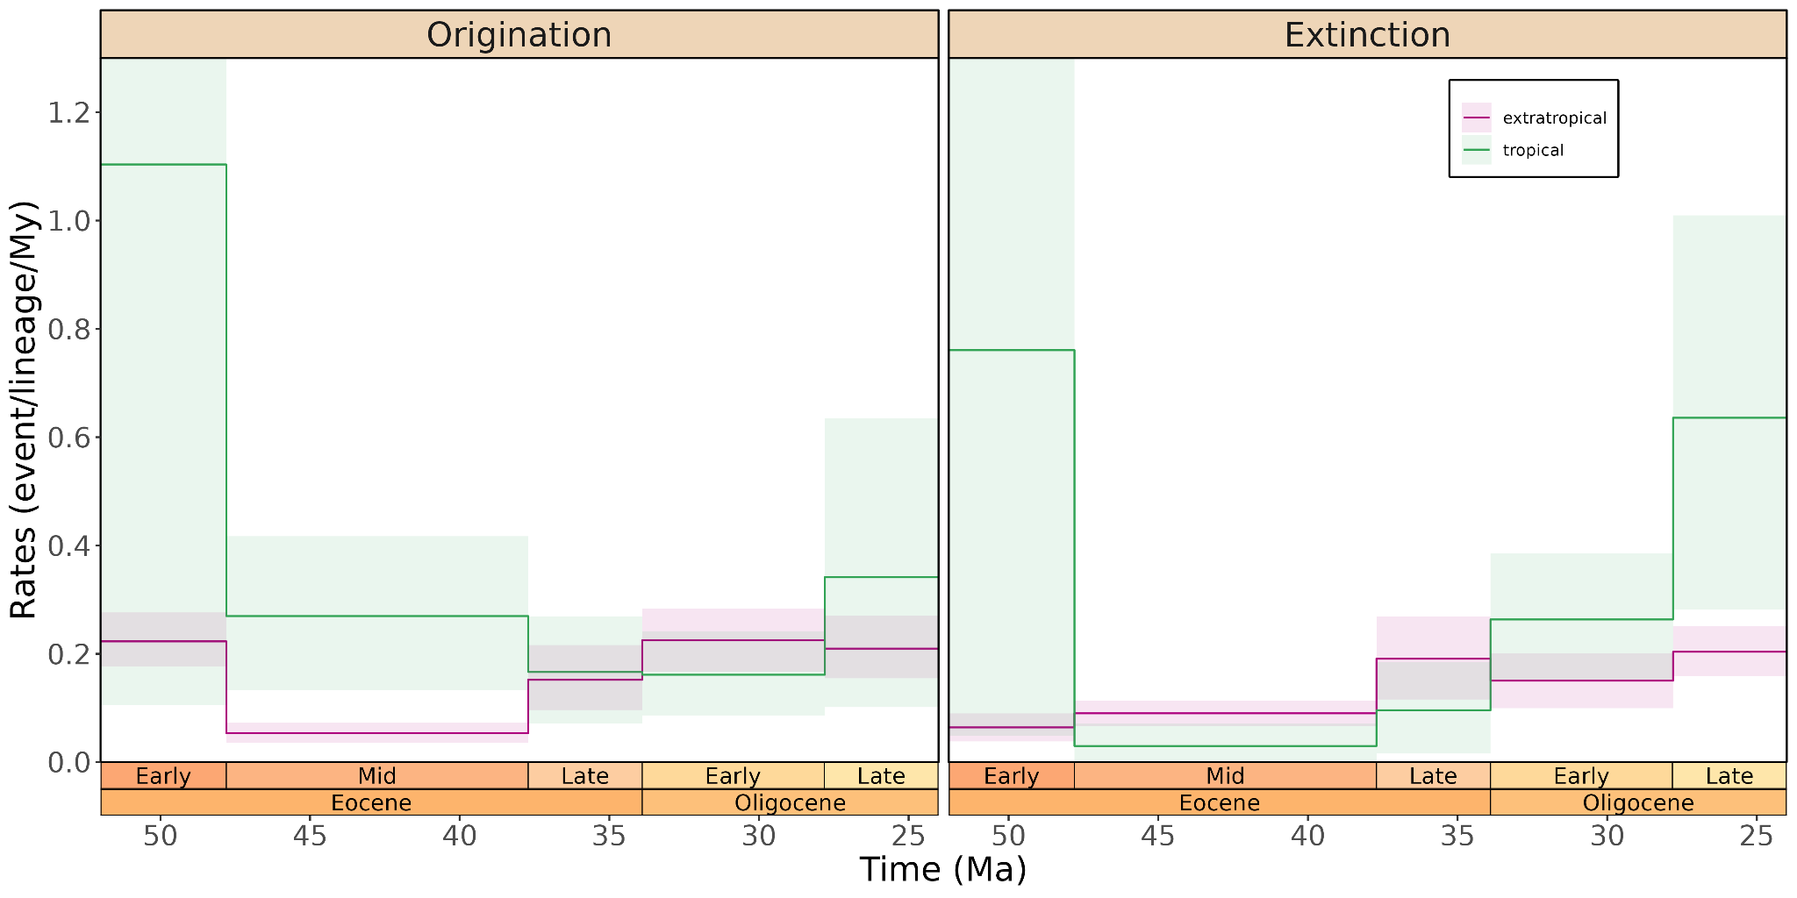

**Figure S25.** Tropical and extratropical origination and extinction rates inferred by the BDCS model allowing for rate shift at every geological stage (SALMA smoothed)**.** Tropical and extratropical rates are respectively shown in green and pink, both for the origination (left) or the extinction (right) rate. SALMAs were smoothed to their corresponding sub-epoch. Geological timescale was added thanks to the deeptime R package [(4)](https://www.zotero.org/google-docs/?eId3XD)**.**

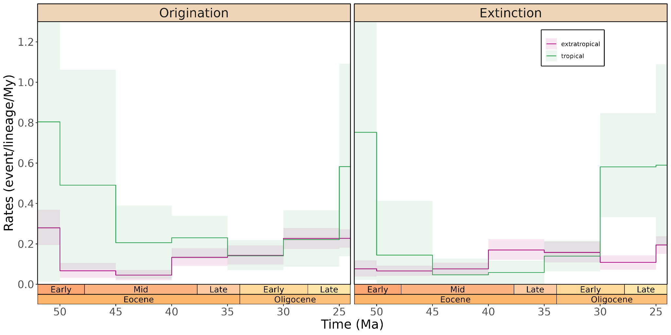

**Figure S26.** Tropical and extratropical origination and extinction rates inferred by the BDCS model allowing for rate shift every 5 My (SALMA smoothed)**.** Tropical and extratropical rates are respectively shown in green and pink, both for the origination (left) or the extinction (right) rate. SALMAs were smoothed to their corresponding sub-epoch. Geological timescale was added thanks to the deeptime R package [(4)](https://www.zotero.org/google-docs/?iM6sp8)**.**

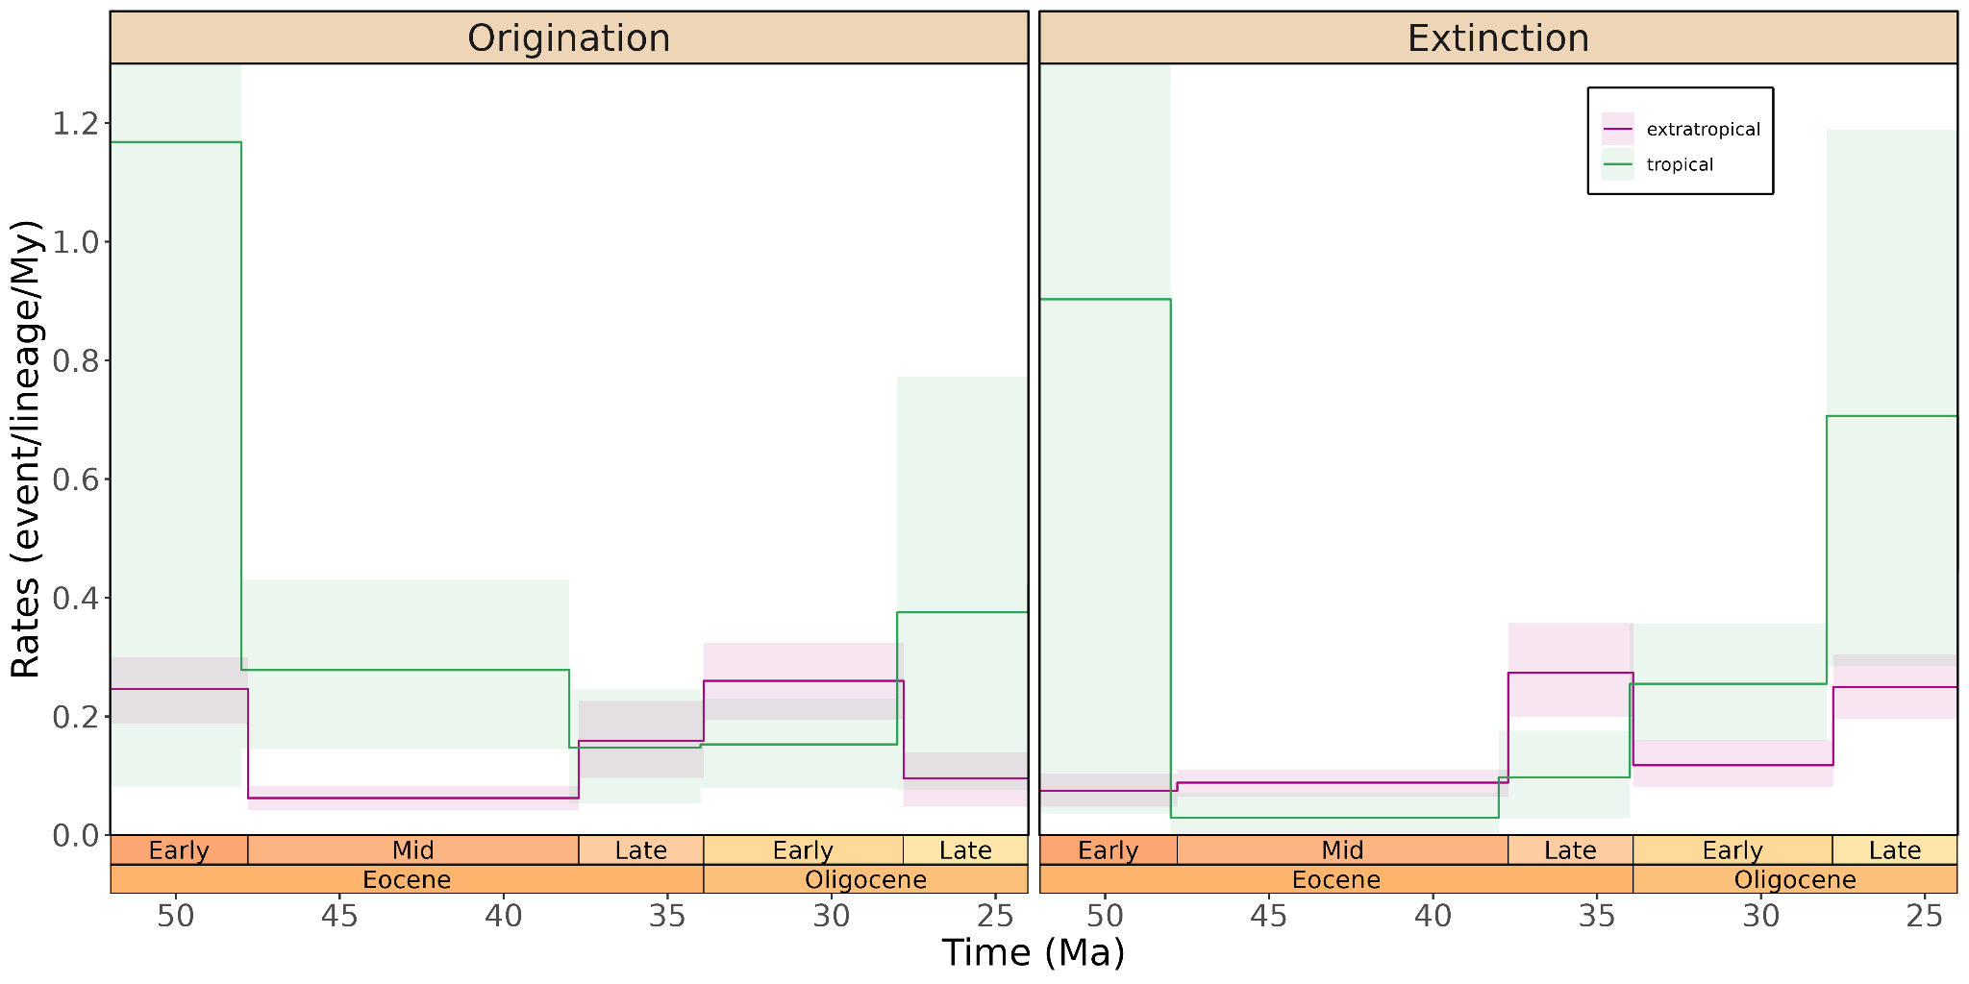

**Figure S27.** Tropical and extratropical origination and extinction rates inferred by the BDCS model allowing for rate shift at every geological stage (SALMA kept).Tropical and extratropical rates are respectively shown in green and pink, both for the origination (left) or the extinction (right) rate. Geological timescale was added thanks to the deeptime R package [(4)](https://www.zotero.org/google-docs/?CBF9Ur)**.**

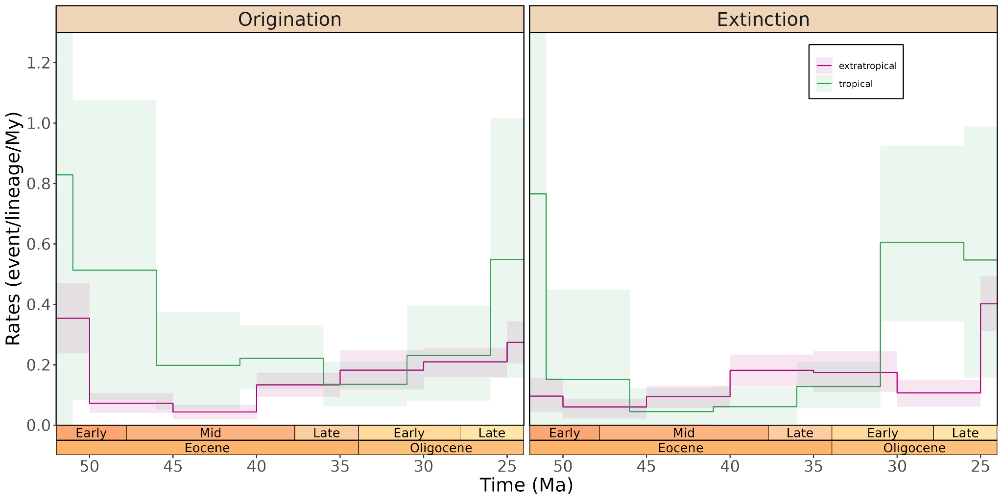

**Figure S28.** Tropical and extratropical origination and extinction rates inferred by the BDCS model allowing for rate shift every 5 My (SALMA kept)**.** Tropical and extratropical rates are respectively shown in green and pink, both for the origination (left) or the extinction (right) rate. Geological timescale was added thanks to the deeptime R package [(4)](https://www.zotero.org/google-docs/?HamK5v)**.**

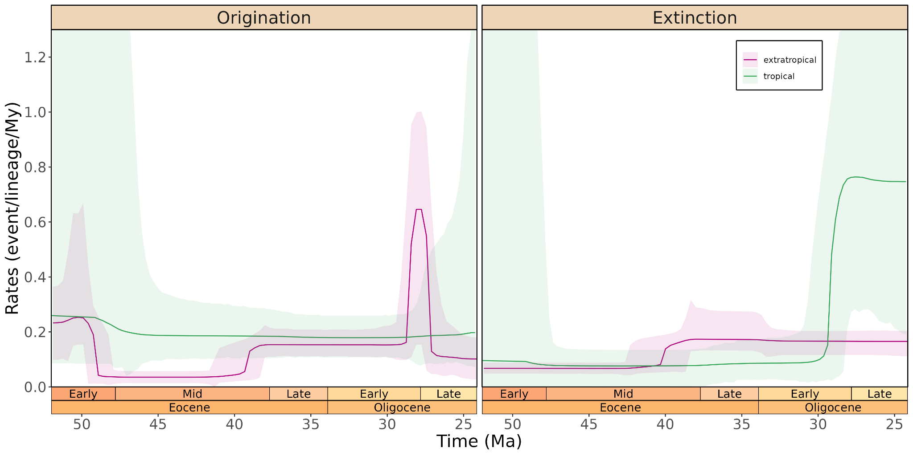

**Figure S29.** Tropical and extratropical origination and extinction rates inferred by the RJMCMC model allowing for rate shift every geological epoch (SALMA smoothed).Tropical and extratropical rates are respectively shown in green and pink, both for the origination (left) or the extinction (right) rate. SALMAs were smoothed to their corresponding sub-epochs. Geological timescale was added thanks to the deeptime R package [(4)](https://www.zotero.org/google-docs/?zrdVJW)**.**

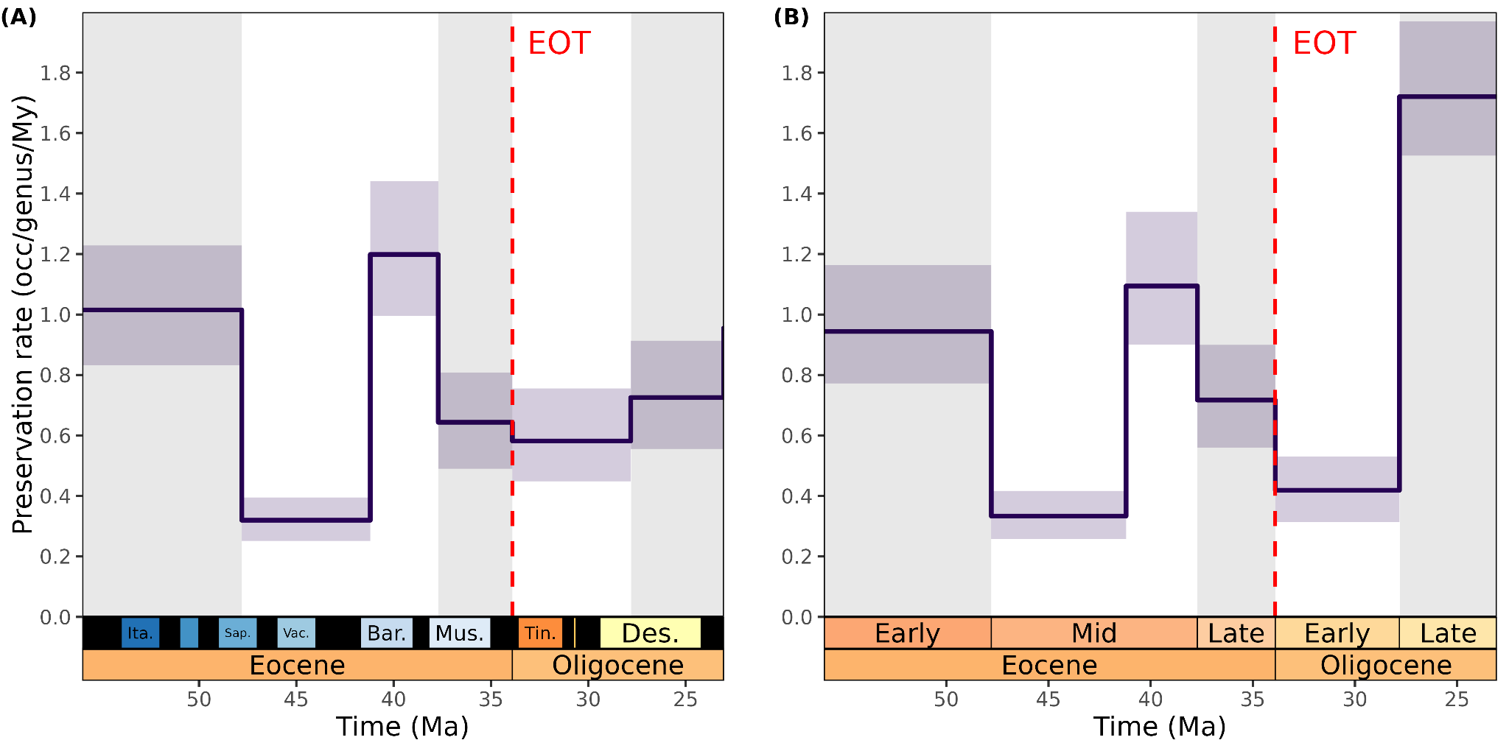

**Figure S30:** Estimates of the preservation rate through time in our genus-level diversification analyses**.** Preservation rate (i.e. estimated number of preserved occurrence per genus and per million years) was estimated both in the analyses with SALMAs kept (**A**) and smoothed to their corresponding sub-epoch (**B**). Solid lines represent the mean posterior estimate, and shaded areas their 95% HPD interval. Red vertical lines show the Eocene-Oligocene Transition (EOT). Geological timescale was added thanks to the deeptime R package [(4)](https://www.zotero.org/google-docs/?laXD8z)**.**

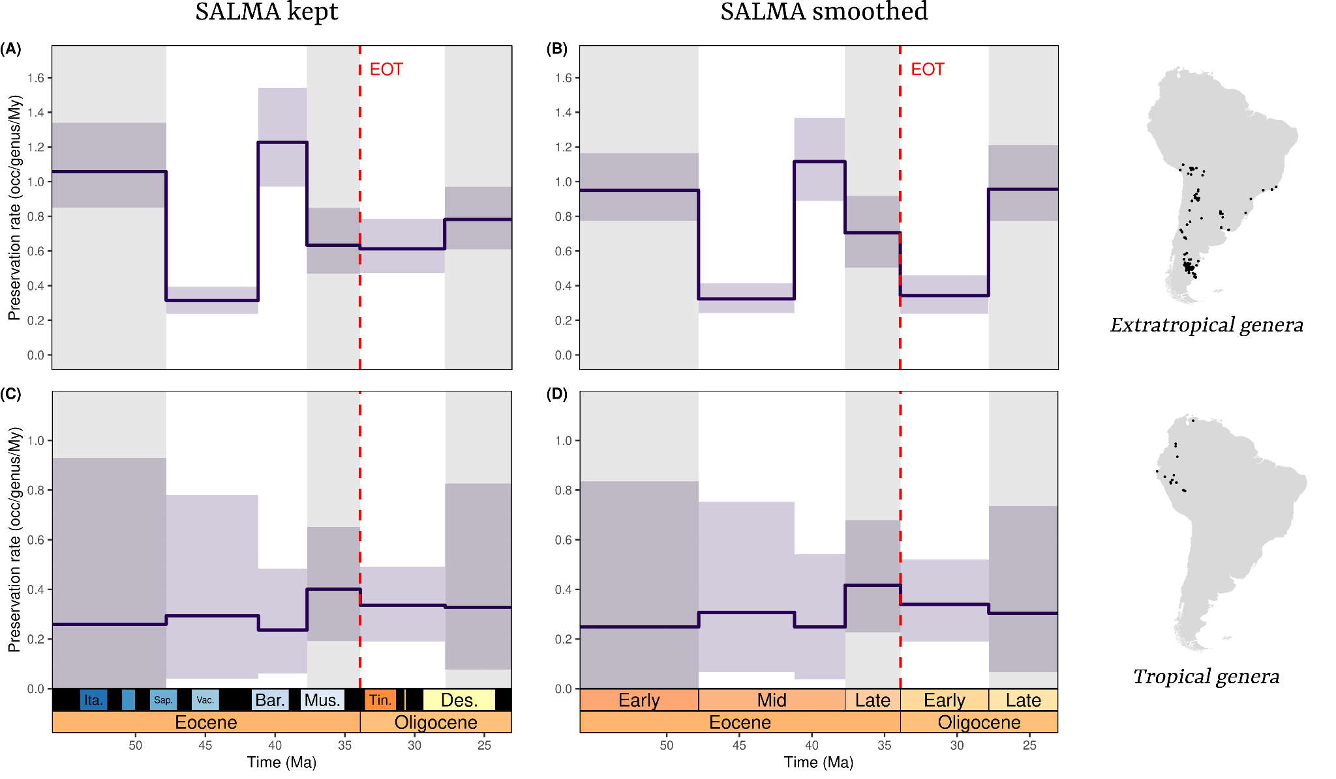**Figure S31:** Estimates of the preservation rate through time and across latitude in our genus-level diversification analyses. Preservation rate (i.e. estimated number of preserved occurrence per genus and per million years) was estimated for Extratropical and tropical genera respectively with SALMAs kept (**A** and **C**) or smoothed to their corresponding sub-epoch (**B** and **D**). Solid lines represent the mean posterior estimate, and shaded areas their 95% HPD interval. Red vertical lines show the Eocene-Oligocene Transition (EOT). Geological timescale was added thanks to the deeptime R package [(4)](https://www.zotero.org/google-docs/?y4OmvL)**.**

**Figure S32:** Estimates of the preservation rate through time in our genus-level diversification analyses after excluding singletons. Preservation rate (i.e. estimated number of preserved occurrence per genus and per million years) was estimated both in the analyses with SALMAs kept (**A**) and smoothed to their corresponding sub-epoch (**B**). Solid lines represent the mean posterior estimate, and shaded areas their 95% HPD interval. Red vertical lines show the Eocene-Oligocene Transition (EOT). Geological timescale was added thanks to the deeptime R package [(4)](https://www.zotero.org/google-docs/?J8yaBF)**.**

**Figure S33:** Estimates of the preservation rate through time in our genus-level diversification analyses after subsetting our dataset to unique locality-lineage combinations.Preservation rate (i.e. estimated number of preserved occurrence per genus and per million years) was estimated both in the analyses with SALMAs kept (**A**) and smoothed to their corresponding sub-epoch (**B**). Solid lines represent the mean posterior estimate, and shaded areas their 95% HPD interval. Red vertical lines show the Eocene-Oligocene Transition (EOT). Geological timescale was added thanks to the deeptime R package [(4)](https://www.zotero.org/google-docs/?IMzDIg)**.**

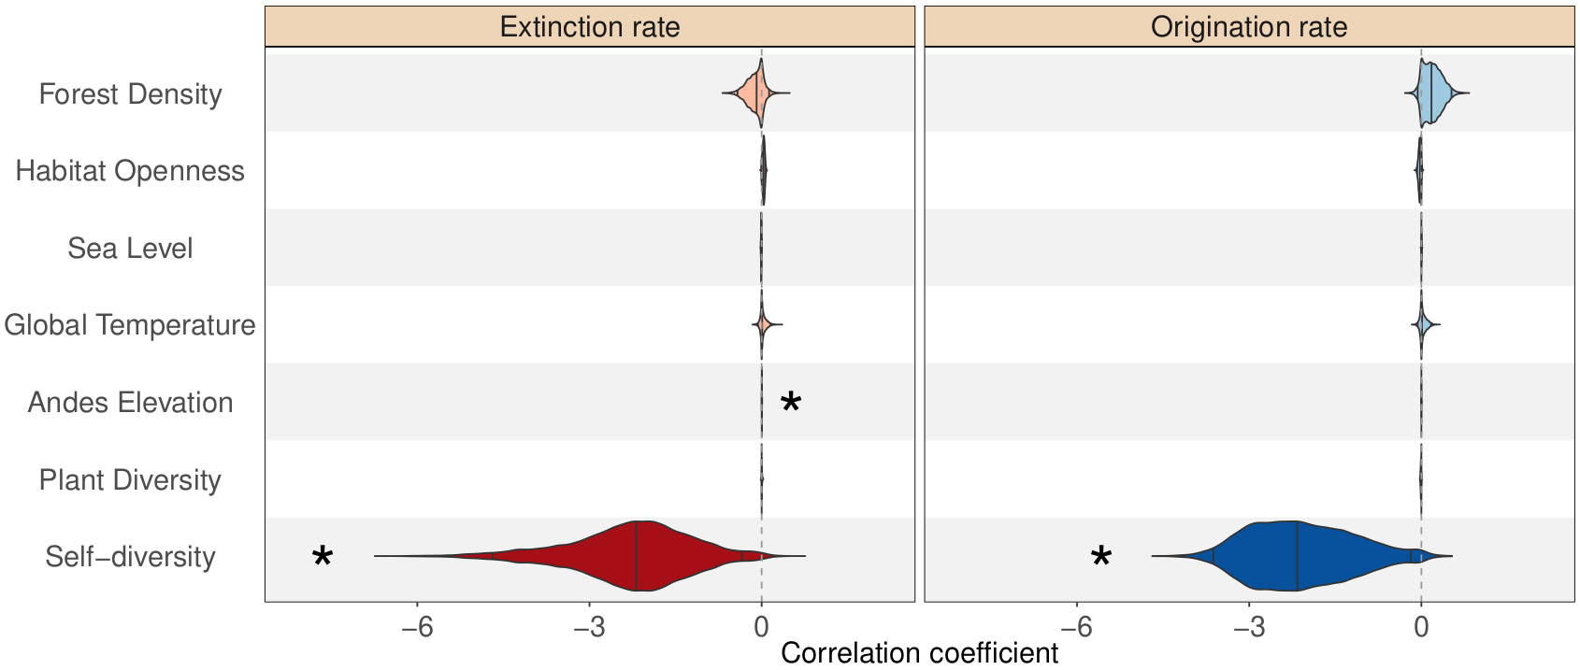

**Figure S34:** Bayesian estimation of correlation parameters on origination (blue) and extinction (red) rates with palaeoenvironmental covariates by considering our dataset as a whole throughout our study period. 2.5%, 50% and 97.5% quantiles are indicated in the distribution of each parameter by vertical lines, respectively from left to right. The interval between the leftmost and the rightmost vertical line of each parameter is therefore its 95% Highest Posterior Density (HPD) interval. Significant correlation coefficients, *i.e.* having shrinkage weights > 0.5 and not including 0 in their 95% HPD are highlighted by stars and darker shades.

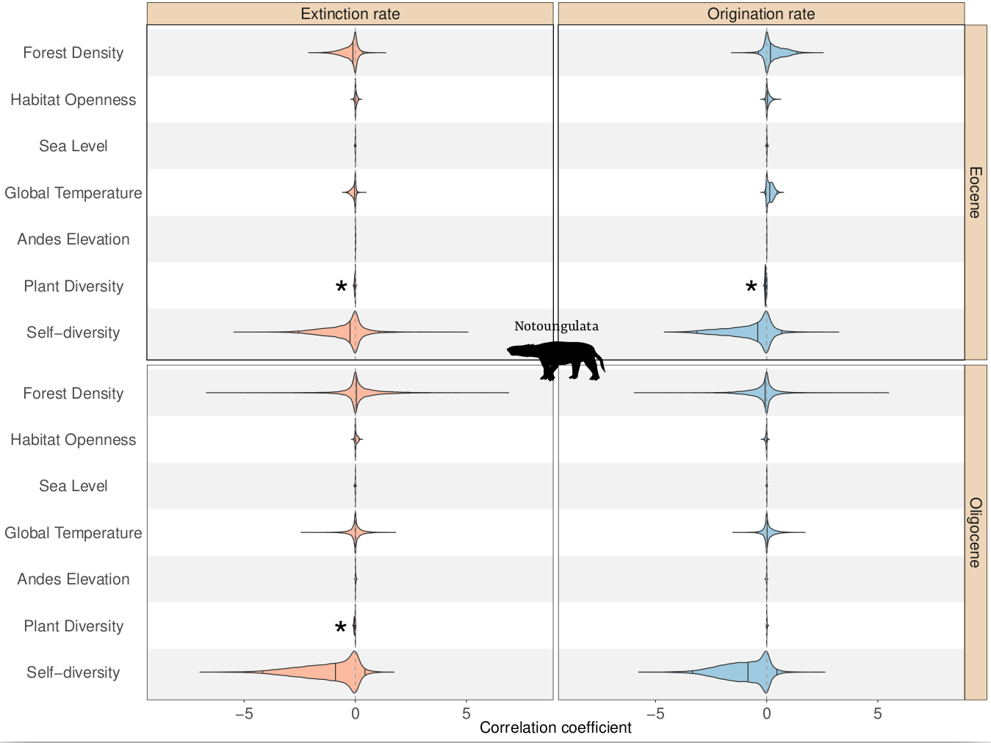

**Figure S35:** Bayesian estimation of correlation parameters on origination (blue) and extinction (red) rates with palaeoenvironmental covariates. We both considered post-Early Eocene Climate Optimum (52-33.9 Ma, top row) and Oligocene (33.9-23.03 Ma, bottom row) notoungulate faunas. 2.5%, 50% and 97.5% quantiles are indicated in the distribution of each parameter by vertical lines, respectively from left to right. The interval between the leftmost and the rightmost vertical line of each parameter is therefore its 95% Highest Posterior Density (HPD) interval. Significant correlation coefficients, *i.e.* having shrinkage weights > 0.5 and not including 0 in their 95% HPD are highlighted by stars and darker shades.

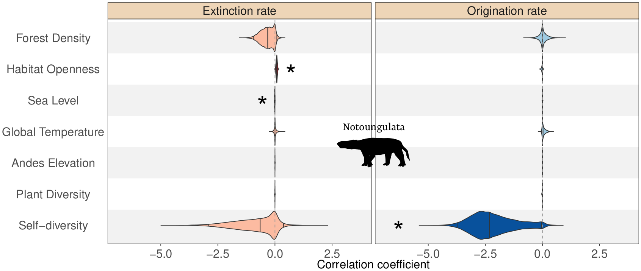

**Figure S36:** Bayesian estimation of correlation parameters on origination (blue) and extinction (red) rates with palaeoenvironmental covariates considering notoungulate faunas as a whole. 2.5%, 50% and 97.5% quantiles are indicated in the distribution of each parameter by vertical lines, respectively from left to right. The interval between the leftmost and the rightmost vertical line of each parameter is therefore its 95% Highest Posterior Density (HPD) interval. Significant correlation coefficients, *i.e.* having shrinkage weights > 0.5 and not including 0 in their 95% HPD are highlighted by stars and darker shades.

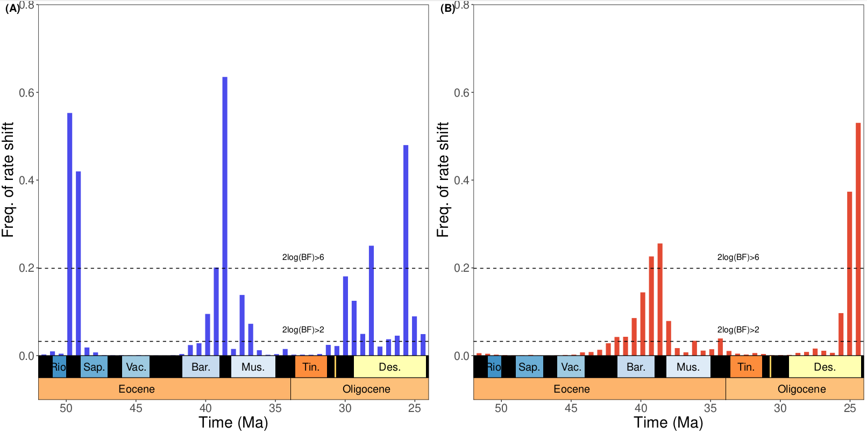

**Figure S37.** Frequency of extinction (**A**) and origination (**B**) rate shifts obtained from analysis of the full genus dataset with RJMCMC (SALMAs kept). Dashed horizontal lines indicate 2 * log Bayes factor of 2 and 6, respectively indicating significant and strongly-supported rate shifts.

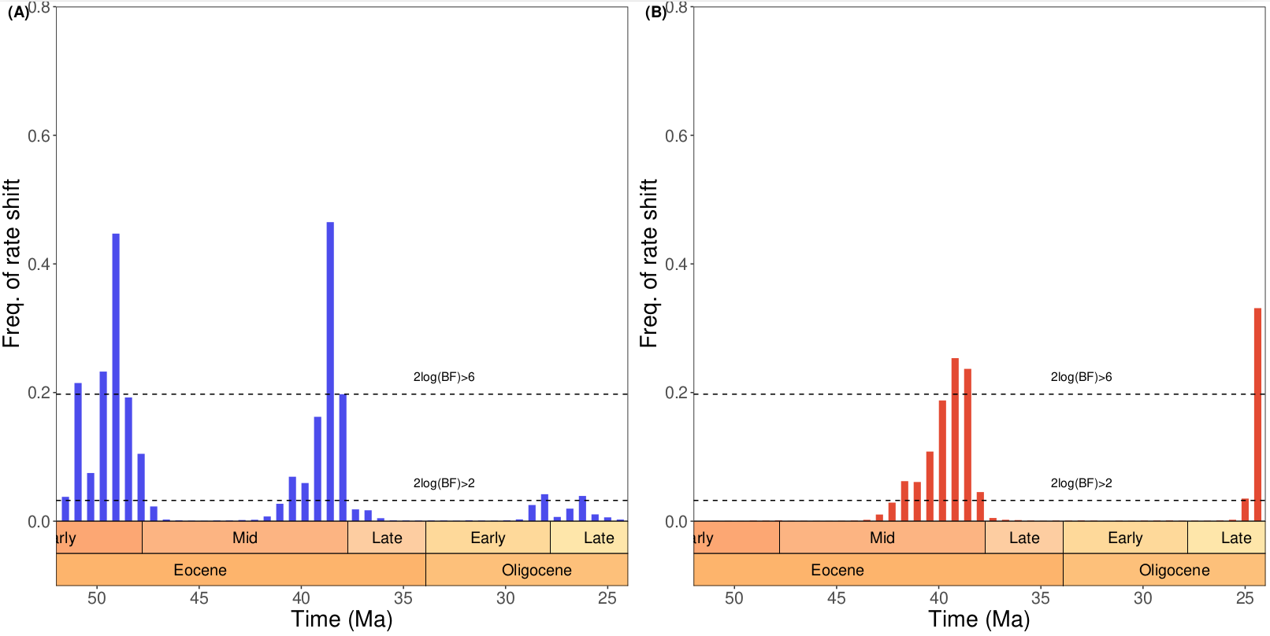**Figure S38.** Frequency of extinction (**A**) and origination (**B**) rate shifts obtained from analysis of the genus dataset with RJMCMC (SALMAs smoothed). Dashed horizontal lines indicate 2 * log Bayes factor of 2 and 6, respectively indicating significant and strongly-supported rate shifts.

|  |  |  |  |  |  |  |  |
| --- | --- | --- | --- | --- | --- | --- | --- |
| order | n_occ | n_gen | n_singl_gen | prop_singl_gen | n_sp | n_singl_sp | prop_singl_sp |
| Astrapotheria | 138 | 15 | 5 | 0.33 | 33 | 19 | 0.58 |
| Chiroptera | 2 | 1 | 0 | 0 | 2 | 2 | 1 |
| Cingulata | 308 | 45 | 16 | 0.36 | 118 | 64 | 0.54 |
| Dasyuromorphia | 3 | 1 | 0 | 0 | 2 | 1 | 0.5 |
| Didelphimorphia | 1 | 1 | 1 | 1 | 1 | 1 | 1 |
| Gondwanatheria | 1 | 1 | 1 | 1 | 1 | 1 | 1 |
| Litopterna | 265 | 53 | 22 | 0.42 | 111 | 64 | 0.58 |
| Microbiotheria | 60 | 8 | 2 | 0.25 | 19 | 8 | 0.42 |
| Notoungulata | 1097 | 137 | 39 | 0.28 | 301 | 147 | 0.49 |
| Paucituberculata | 162 | 24 | 10 | 0.42 | 47 | 28 | 0.6 |
| Pilosa | 117 | 26 | 14 | 0.54 | 54 | 33 | 0.61 |
| Polydolopimorphia | 107 | 16 | 4 | 0.25 | 40 | 21 | 0.52 |
| Primates | 57 | 14 | 9 | 0.64 | 19 | 11 | 0.58 |
| Pyrotheria | 48 | 8 | 2 | 0.25 | 20 | 10 | 0.5 |
| Rodentia | 700 | 101 | 31 | 0.31 | 216 | 110 | 0.51 |
| Sparassodonta | 218 | 29 | 7 | 0.24 | 49 | 21 | 0.43 |
| Xenungulata | 4 | 2 | 1 | 0.5 | 4 | 4 | 1 |
| **Total** | **3384** | **529** | **190** | **0.36** | **1108** | **599** | **0.54** |

**Table S1.** Number of occurrences (*n_occ*), of genera (*n_gen*), of species (*n_sp*), of singleton (*i.e.* genera or species only represented by a single occurrence, *n_singl_gen* and *n_singl_sp* respectively) and proportion of singletons (*prop_singl_gen* and *prop_singl_sp*) per order. The 96 occurrences (49 genera) without specified order are not displayed here, but counted in the ‘Total’ row.

|  |  |  |  |
| --- | --- | --- | --- |
| **Covariate** | **Description** | **Unit** | **Source** |
| Temperature | Global average temperature across the Cenozoic derived from oxygen isotopes generated using benthic Foraminifera | °C | Boshman and Condamine (2022) from Westerhold et al. (2020) |
| Andean uplift | Elevation data compiled from 36 geomorphological domains all across the Andes | m | Boschman (2021) |
| Sea level | Global eustatic variations derived from d18O and Mg/Ca records | m | Miller et al. (2020) |
| Neotropical plant diversity | Cenozoic (66-20 Ma) plant diversity in the Neotropics | nb. taxa | Jaramillo et al. (2006) |
| Habitat openness | Temporal patterns in the relative abundance of open habitats in Patagonia | nb. plant taxa | Solórzano et Nuñez (2021) from Palazzesi et Berrada (2012) and Dunn et al. (2015) |
| Relative Leaf Area Index (rLAI) | Quotient between leaf and ground areas, obtained via phytolith quantification on fossil leaves from Patagonia. Proxy for forest density. | m²/m² | Solórzano et Nuñez (2021) from Dunn et al. (2015) |

**Table S2.** Selected environmental variables chosen for the Multivariate Birth-Death analysis

|  |  |  |  |  |
| --- | --- | --- | --- | --- |
| Covariate | G𝜆 | G𝜆 95% HPD | w𝜆 | w𝜆 95% HPD |
| **Self-diversity** | **-3.2398065** | **[-4.749368; -1.462309125]** | **0.8922875** | **[0.482064375; 0.995827425]** |
| Plant Diversity | -0.0013 | [-0.034406275; 0.0213525] | 0.2827295 | [0.0006599; 0.9620882] |
| Andes Elevation | 0.0003565 | [-0.002929475; 0.0080708] | 0.251413 | [0.000437625; 0.962260775] |
| **Global Temperature** | **0.235658** | **[-0.004139975; 0.49186785]** | **0.8249115** | **[0.02495975; 0.994773025]** |
| Sea Level | 0.010382 | [-0.0058303; 0.04118235] | 0.432651 | [0.001355075; 0.976947675] |
| Habitat Openness | 0.0865535 | [-0.028921375; 0.2637306] | 0.4288735 | [0.00143015; 0.971594375] |
| Forest Density | 0.016564 | [-0.55230105; 0.689823525] | 0.2210625 | [0.000495; 0.953961525] |

**Table S3.** Posterior estimates of the multivariate birth-death correlation parameters with the origination rate (G𝜆) for our full Eocene (52-33.9 Ma) dataset, and their associated Shrinkage weights (w𝜆). Median estimates are shown along with their 95% Highest Posterior Density (HPD) interval. Significant correlations, *i.e.* having a w𝜆 larger than 0.5 and of which the 95% HPD of the associated coefficients do not overlap 0 are shown in bold. In the case of temperature, the proportion of the posterior distribution of the associated G𝜆 below 0 is around 0.0348. Although this is larger than 0.0250, we consider it small enough to claim for a significant correlation.

|  |  |  |  |  |
| --- | --- | --- | --- | --- |
| Covariate | Gµ | Gµ 95% HPD | wµ | wµ 95% HPD |
| Self-diversity | -0.68536 | [-2.65502845; 0.5676114] | 0.463017 | [0.001845; 0.9809005] |
| Plant Diversity | -0.0075055 | [-0.038847; 0.010897325] | 0.3591375 | [0.001071225; 0.970024675] |
| Andes Elevation | 0.002211 | [-0.00081475; 0.0069251] | 0.4170665 | [0.001937775; 0.97429505] |
| Global Temperature | -0.0545555 | [-0.26240435; 0.059415925] | 0.4206875 | [0.0012501; 0.9772167] |
| Sea Level | -0.0025505 | [-0.024880425; 0.010679275] | 0.2308495 | [0.0004799; 0.948354175] |
| Habitat Openness | 0.000783 | [-0.081494075; 0.0720805] | 0.1094145 | [0.0001649; 0.9239618] |
| Forest Density | -0.023639 | [-0.511065775; 0.372882] | 0.1856625 | [0.000476175; 0.946618725] |

**Table S4.** Posterior estimates of the multivariate birth-death correlation parameters with the extinction rate (Gμ) for our full Eocene (52-33.9 Ma) dataset, and their associated Shrinkage weights (wµ). Median estimates are shown along with their 95% Highest Posterior Density (HPD) interval.

|  |  |  |  |  |
| --- | --- | --- | --- | --- |
| Covariate | G𝜆 | G𝜆 95% HPD | w𝜆 | w𝜆 95% HPD |
| Self-diversity | -0.87246 | [-2.399400025; 0.204207725] | 0.4842475 | [0.002408975; 0.9733799] |
| Plant Diversity | 0.0103475 | [-0.002931125; 0.035964375] | 0.505214 | [0.0019264; 0.9813595] |
| Andes Elevation | -0.0016715 | [-0.02249305; 0.008461475] | 0.289628 | [0.000599175; 0.968955025] |
| Global Temperature | 0.0204325 | [-0.454191325; 0.578650075] | 0.2324325 | [0.000549625; 0.95185725] |
| Sea Level | -0.000341 | [-0.01188855; 0.00814649999999999] | 0.1486455 | [0.00025845; 0.928946025] |
| Habitat Openness | -0.0105925 | [-0.101360575; 0.02381495] | 0.202531 | [0.000557; 0.949999925] |
| Forest Density | -0.007085 | [-1.024331; 1.179334375] | 0.2081845 | [0.000430725; 0.95873745] |

**Table S5.** Posterior estimates of the multivariate birth-death correlation parameters with the origination rate (G𝜆) for our full Oligocene (33.9-23.03 Ma) dataset, and their associated Shrinkage weights (w𝜆). Median estimates are shown along with their 95% Highest Posterior Density (HPD) interval.

|  |  |  |  |  |
| --- | --- | --- | --- | --- |
| Covariate | Gµ | Gµ 95% HPD | wµ | wµ 95% HPD |
| **Self-diversity** | **-2.434002** | **[-3.936475975; -0.811495225]** | **0.8327275** | **[0.310880325; 0.993577775]** |
| Plant Diversity | -0.002433 | [-0.047192775; 0.0122242] | 0.3442905 | [0.000613625; 0.98136075] |
| **Andes Elevation** | **0.0254835** | **[-0.001033475; 0.0562333]** | **0.874853** | **[0.02483225; 0.99591]** |
| Global Temperature | -0.008511 | [-0.7623435; 0.4636399] | 0.200259 | [0.00043545; 0.95860845] |
| Sea Level | -0.000463 | [-0.013189475; 0.01579585] | 0.1699725 | [0.00030345; 0.944847525] |
| Habitat Openness | -0.0050775 | [-0.103321725; 0.05010885] | 0.2349245 | [0.000478725; 0.9598869] |
| Forest Density | 0.0582375 | [-1.32810455; 2.632092775] | 0.3263365 | [0.000489625; 0.982877875] |

**Table S6.** Posterior estimates of the multivariate birth-death correlation parameters with the extinction rate (Gμ) for our full Oligocene (33.9-23.03 Ma) dataset, and their associated Shrinkage weights (wµ). Median estimates are shown along with their 95% Highest Posterior Density (HPD) interval. Significant correlations, *i.e.* having a wµ larger than 0.5 and of which the 95% HPD of the associated coefficients do not overlap 0 are shown in bold. In the case of Andean elevation, the proportion of the posterior distribution of the associated Gµ below 0 is around 0.045. Although this is larger than 0.0250, we consider it small enough to claim for a significant correlation.

|  |  |  |  |  |
| --- | --- | --- | --- | --- |
| Covariate | G𝜆 | G𝜆 95% HPD | w𝜆 | w𝜆 95% HPD |
| **Self-diversity** | **-2.1570185** | **[-3.599959675; -0.17079245]** | **0.79836** | **[0.10377875; 0.992090675]** |
| Plant Diversity | -0.0057125 | [-0.019646275; 0.001921275] | 0.496629 | [0.001445625; 0.979166825] |
| Andes Elevation | 0.000226 | [-0.001194; 0.003123] | 0.1968805 | [0.000335625; 0.951102] |
| Global Temperature | 0.012602 | [-0.06275025; 0.1700887] | 0.2785785 | [0.000556725; 0.96749785] |
| Sea Level | 0.0016365 | [-0.0041742; 0.010726475] | 0.22427 | [0.00046845; 0.950243525] |
| Habitat Openness | -0.0245785 | [-0.0731432; 0.00710965] | 0.2844605 | [0.00119645; 0.9552013] |
| Forest Density | 0.177091 | [-0.05988555; 0.526311825] | 0.2717145 | [0.001010625; 0.95251125] |

**Table S7.** Posterior estimates of the multivariate birth-death correlation parameters with the origination rate (G𝜆) for our full dataset (56-23.03 Ma), and their associated Shrinkage weights (w𝜆). Median estimates are shown along with their 95% Highest Posterior Density (HPD) interval. Significant correlations, *i.e.* having a w𝜆 larger than 0.5 and of which the 95% HPD of the associated coefficients do not overlap 0 are shown in bold.

|  |  |  |  |  |
| --- | --- | --- | --- | --- |
| Covariate | Gµ | Gµ 95% HPD | wµ | wµ 95% HPD |
| **Self-diversity** | **-2.182159** | **[-4.66551245; -0.339009825]** | **0.8112565** | **[0.154939975; 0.993549825]** |
| Plant Diversity | 0.0011585 | [-0.00583755; 0.017200475] | 0.2718125 | [0.00056235; 0.96768825] |
| **Andes Elevation** | **0.003042** | **[0.00023035; 0.006699275]** | **0.7032355** | **[0.058645975; 0.986970575]** |
| Global Temperature | 0.0091805 | [-0.063008025; 0.1553182] | 0.2463615 | [0.0004859; 0.957209] |
| Sea Level | -0.006604 | [-0.014887825; 0.000948099999999999] | 0.454797 | [0.00385745; 0.974076925] |
| Habitat Openness | 0.0350945 | [-0.000531825; 0.0698661] | 0.381871 | [0.006823275; 0.9614739] |
| Forest Density | -0.0860185 | [-0.4199787; 0.1295882] | 0.1778275 | [0.00040345; 0.9275904] |

**Table S8.** Posterior estimates of the multivariate birth-death correlation parameters with the extinction rate (Gµ) for our full dataset (56-23.03 Ma), and their associated Shrinkage weights (wµ). Median estimates are shown along with their 95% Highest Posterior Density (HPD) interval. Significant correlations, *i.e.* having a wµ larger than 0.5 and of which the 95% HPD of the associated coefficients do not overlap 0 are shown in bold.

**SI References**

[1. R. E. Dunn, *et al.*, A new chronology for middle Eocene–early Miocene South American Land Mammal Ages. *GSA Bull.* **125**, 539–555 (2013).](https://www.zotero.org/google-docs/?lP83YO)

[2. M. O. Woodburne, *et al.*, Paleogene Land Mammal Faunas of South America; a Response to Global Climatic Changes and Indigenous Floral Diversity. *J. Mamm. Evol.* **21**, 1–73 (2014).](https://www.zotero.org/google-docs/?lP83YO)

[3. M. Kouvari, “Palaeoenvironmental constraints on the diversity of eutherian terrestrial mammals through the  Cenozoic of South America, and the emergence of the modern-day latitudinal biodiversity gradient on the continent,”  University College of London. (2023).](https://www.zotero.org/google-docs/?lP83YO)

[4. W. Gearty, deeptime: Plotting Tools for Anyone Working in Deep Time. R package version 1.0.1. (2023). Deposited 2023.](https://www.zotero.org/google-docs/?lP83YO)

[5. W. Gearty, L. A. Jones, rphylopic: An R package for fetching, transforming, and visualising PhyloPic silhouettes. *Methods Ecol. Evol.* **14**, 2700–2708 (2023).](https://www.zotero.org/google-docs/?lP83YO)

[6. P.-O. Antoine, *et al.*, A 60-million-year Cenozoic history of western Amazonian ecosystems in Contamana, eastern Peru. *Gondwana Res.* **31**, 30–59 (2016).](https://www.zotero.org/google-docs/?lP83YO)

[7. A. Solórzano, M. Núñez-Flores, Evolutionary trends of body size and hypsodonty in notoungulates and their probable drivers. *Palaeogeogr. Palaeoclimatol. Palaeoecol.* **568**, 110306 (2021).](https://www.zotero.org/google-docs/?lP83YO)

[8. F. J. Goin, M. O. Woodburne, A. N. Zimicz, G. M. Martin, L. Chornogubsky, *A brief history of South American Metatherians: evolutionary contexts and intercontinental dispersals*, Springer Dordrecht (2016).](https://www.zotero.org/google-docs/?lP83YO)

[9. R. M. D. Beck, The Skull of Epidolops ameghinoi from the Early Eocene Itaboraí Fauna, Southeastern Brazil, and the Affinities of the Extinct Marsupialiform Order Polydolopimorphia. *J. Mamm. Evol.* **24**, 373–414 (2017).](https://www.zotero.org/google-docs/?lP83YO)

[10. G. Billet, Phylogeny of the Notoungulata (Mammalia) based on cranial and dental characters. *J. Syst. Palaeontol.* **9**, 481–497 (2011).](https://www.zotero.org/google-docs/?lP83YO)